## [What is the difference between policy-based, on-policy, value-based, off-policy, model-free and model-based?](https://stats.stackexchange.com/questions/407230/what-is-the-difference-between-policy-based-on-policy-value-based-off-policy)

I'm trying to clear things out for myself, there are a lot of different categorizations within RL. Some people talk about:

* On-policy & Off-Policy
* Model-based & Model-free
* Model-based, Policy-based & Value-based (+ Actor-Critic= Policy-based+Value-based)

It seems like there is some overlap, which led me to the next understanding:

**Model-based**

**Model-free:**

* Policy-based = On-policy:
  + Deterministic
  + Stochastic
* Value-based = Off-Policy
* Actor-Critic = Value-based(Actor) + Policy-based(Critic)

Is this understanding right or are they all completely different categorizations?

2 Answers

1:

You can have an on-policy RL algorithm that is value-based. An example of such algorithm is SARSA, so not all value-based algorithms are off-policy. A value-based algorithm is just an algorithm that estimates the policy by first estimating the associated value function.

To understand the difference between on-policy and off-policy, you need to understand that there are **two phases** of an RL algorithm: the learning (or training) phase and the inference (or behaviour) phase (after the training phase). The distinction between on-policy and off-policy algorithms only concerns the training phase.

During the learning phase, the RL agent needs to learn an estimate of the optimal value (or policy) function. Given that the agent still does not know the optimal policy, it often behaves *sub-optimally*. During training, the agent faces a dilemma: the exploration or exploitation dilemma. In the context of RL, exploration and exploitation are different concepts: exploration is the selection and execution (in the environment) of an action that is likely not optimal (according to the knowledge of the agent) and exploitation is the selection and execution of an action that is optimal according to the agent's knowledge (that is, according to the agent's current best estimate of the optimal policy). During the training phase, the agent needs to explore and exploit: the exploration is required to discover more about the optimal strategy, but the exploitation is also required to know even more about the already visited and partially known states of the environment. During the learning phase, the agent thus can't just exploit the already visited states, but it also needs to explore possibly unvisited states. To explore possibly unvisited states, the agent often needs to perform a sub-optimal action.

An *off-policy* algorithm is an algorithm that, during training, uses a behaviour policy (that is, the policy it uses to select actions) that is different than the optimal policy it tries to estimate (the optimal policy). For example, [𝑄Q-learning](https://en.wikipedia.org/wiki/Q-learning) often uses an 𝜖ϵ-greedy policy (𝜖ϵ percentage of the time it chooses a random or explorative action and 1−𝜖1−ϵ percentage of the time it chooses the action that is optimal, according to its current best estimate of the optimal policy) to behave (that is, to exploit and explore the environment), while, in its update rule, because of the maxmax operator, it assumes that the greedy action (that is, the current optimal action in a given state) is chosen.

An *on-policy* algorithm is an algorithm that, during training, chooses actions using a policy that is derived from the current estimate of the optimal policy, while the updates are also based on the current estimate of the optimal policy. For example, [SARSA](https://en.wikipedia.org/wiki/State%E2%80%93action%E2%80%93reward%E2%80%93state%E2%80%93action) is an on-policy algorithm because it doesn't use the maxmax operator in its update rule.

The difference between 𝑄Q-learning (off-policy) and SARSA (on-policy) is respectively the use or not of the maxmax operator in their update rule.

In the case of policy-based or policy search algorithm (e.g. REINFORCE), the distinction between on-policy and off-policy is often not made because, in this context, there isn't usually a clear separation between a behaviour policy (the policy to behave during training) and a target policy (the policy to be estimated).

You can think of actor-critic algorithms as value and policy-based because they use both a value and policy functions.

The usual examples of model-based algorithms are value and policy iterations, which are algorithms that **use** the transition and reward functions (of the given Markov decision process) to estimate the value function. However, it might be the case that you also have on-policy, off-policy, value-based or policy-based algorithms that are model-based, in some way, that is, they might use a model of the environment in some way.

[share](https://stats.stackexchange.com/a/407745)  cite  [improve this answer](https://stats.stackexchange.com/posts/407745/edit)  follow

[edited May 20 '19 at 10:59](https://stats.stackexchange.com/posts/407745/revisions)

answered May 10 '19 at 21:14

[[](https://stats.stackexchange.com/users/82135/nbro)](https://stats.stackexchange.com/users/82135/nbro)

[nbro](https://stats.stackexchange.com/users/82135/nbro)

**2,064**11 gold badge1414 silver badges2828 bronze badges

* I think you made a type in the on-policy paragraph " For example, SARSA is an off-policy algorithm" shouldn't it be on-policy? Also I'm missing the context on the max operator, which I assume indicates my unfamiliarity with the field. But thanks for the information! – [Dave Ouds](https://stats.stackexchange.com/users/247246/dave-ouds) [May 20 '19 at 10:17](https://stats.stackexchange.com/questions/407230/what-is-the-difference-between-policy-based-on-policy-value-based-off-policy#comment764439_407745)
* @DaveOuds Yes, it was a typo. Thanks for pointing this out. Have a look at the update rules of Q-learning and SARSA. You will see that Q-learning uses a maxmax, but SARSA doesn't. – [nbro](https://stats.stackexchange.com/users/82135/nbro" \o "2,064 reputation) [May 20 '19 at 11:00](https://stats.stackexchange.com/questions/407230/what-is-the-difference-between-policy-based-on-policy-value-based-off-policy#comment764451_407745)

[add a comment](https://stats.stackexchange.com/questions/407230/what-is-the-difference-between-policy-based-on-policy-value-based-off-policy)

Here is a quick summary on the Reinforcement Learning taxonomy:

On-policy vs. Off-Policy

This division is based on whether you update your 𝑄Q values based on actions undertaken according to your current policy or not. Let's say your current policy is a completely *random policy*. You're in state 𝑠s and make an action 𝑎a that leads you to state 𝑠′s′. will you update your 𝑄(𝑠,𝑎)Q(s,a)based on the best possible action you can take in 𝑠′s′ or based on an action according to your current policy (random action)? The first choice method is called **off-policy** and the latter - **on-policy**. E.g. *Q-learning* does the first and *SARSA* does the latter.

Policy-based vs. Value-based

In **Policy-based** methods we explicitly build a representation of a policy (mapping 𝜋:𝑠→𝑎π:s→a) and keep it in memory during learning.

In **Value-based** we don't store any explicit policy, only a value function. The policy is here implicit and can be derived directly from the value function (pick the action with the best value).

**Actor-critic** is a mix of the two.

Model-based vs. Model-free

The problem we're often dealing with in RL is that whenever you are in state 𝑠s and make an action 𝑎a you might not necessarily know the next state 𝑠′s′ that you'll end up in (the environment influences the agent).

In **Model-based** approach you either have an access to the model (environment) so you know the probability distribution over states that you end up in, or you first try to build a model (often - approximation) yourself. This might be useful because it allows you to do *planning* (you can "think" about making moves ahead without actually performing any actions).

In **Model-free** you're not given a model and you're not trying to explicitly figure out how it works. You just collect some experience and then derive (hopefully) optimal policy.

## Policy Gradient:

GAE: HIGH-DIMENSIONAL CONTINUOUS CONTROL USING GENERALIZED ADVANTAGE ESTIMATION

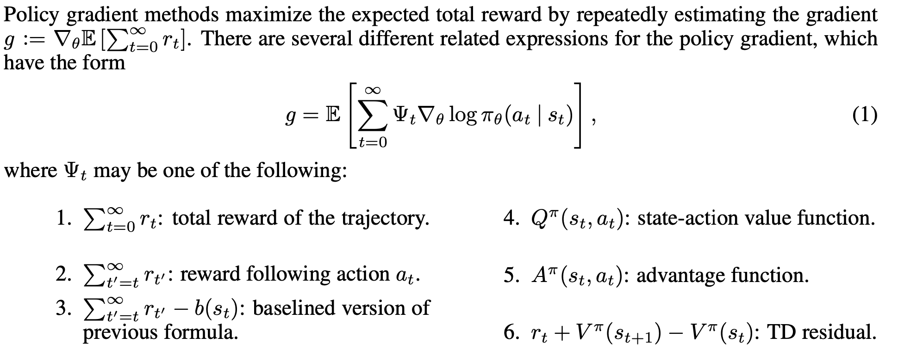

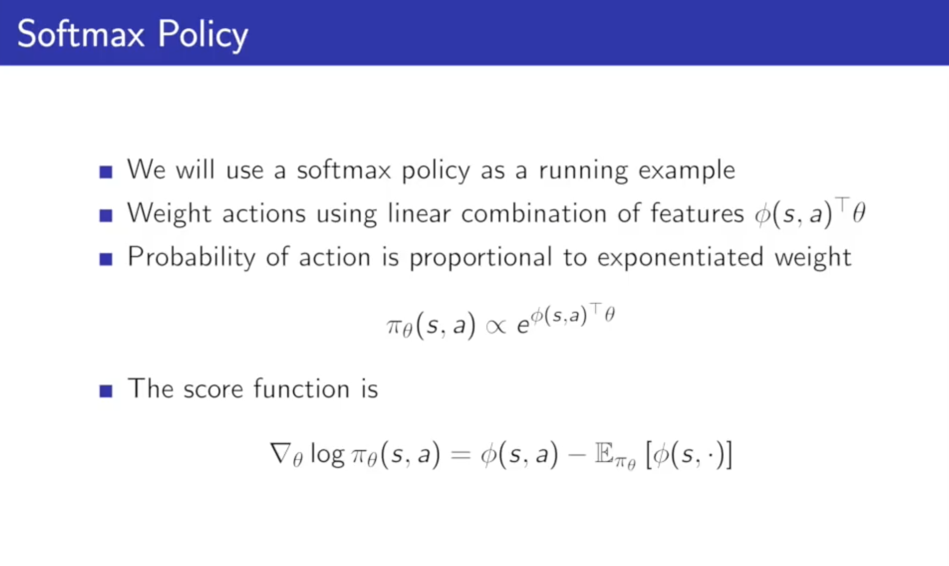

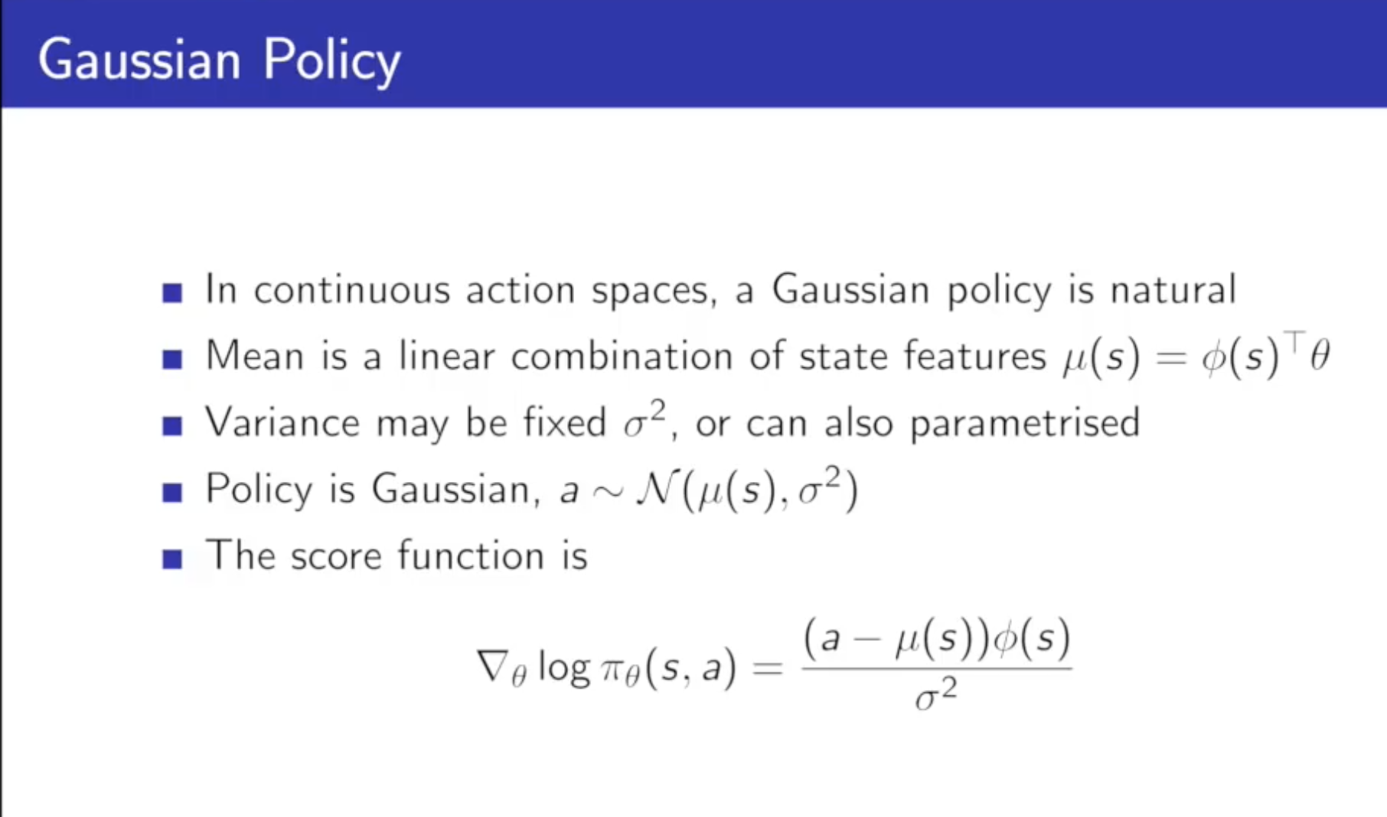

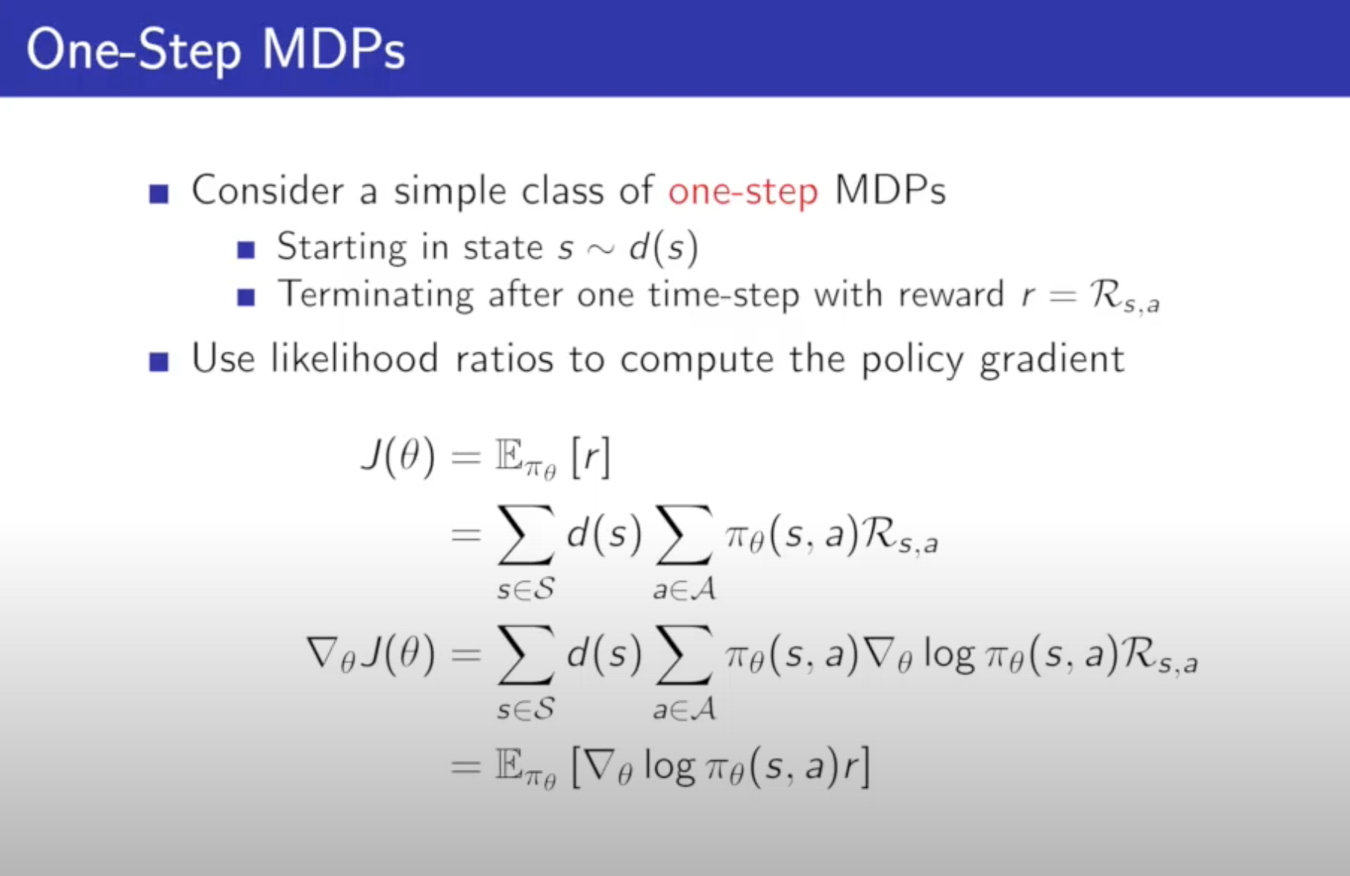

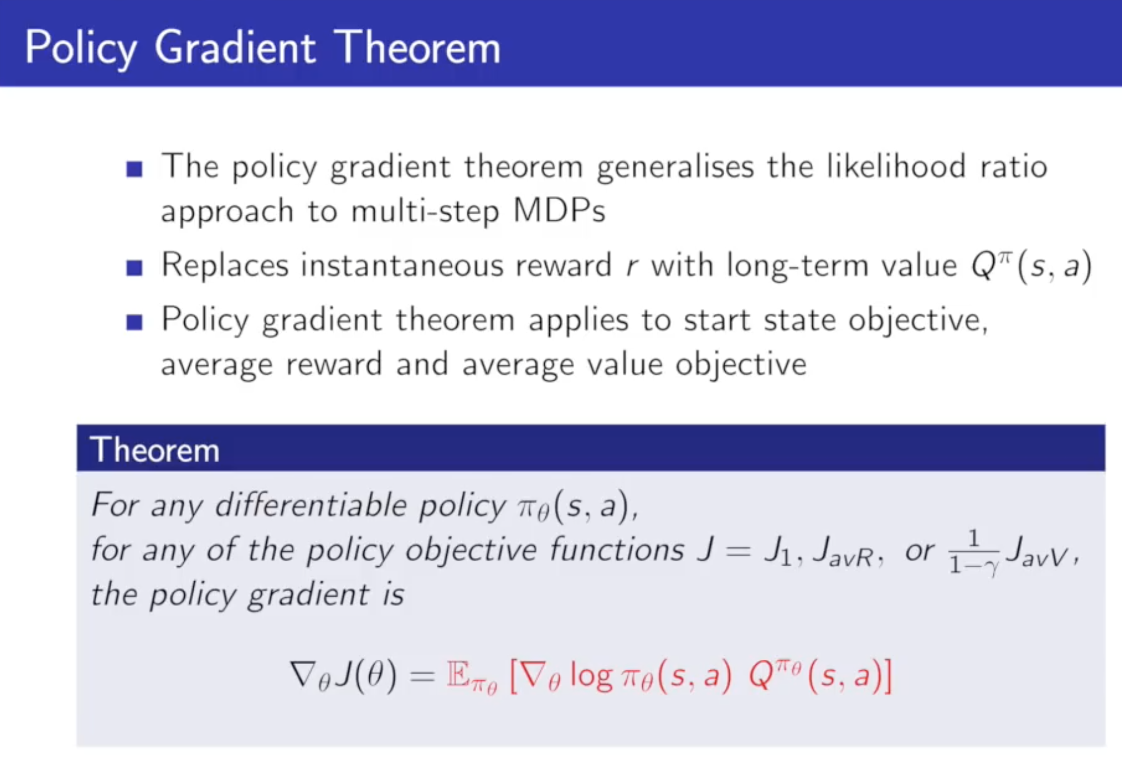

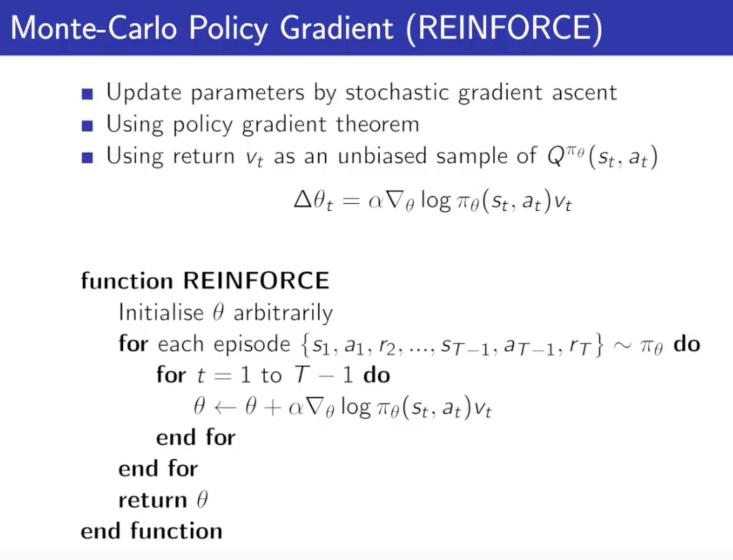

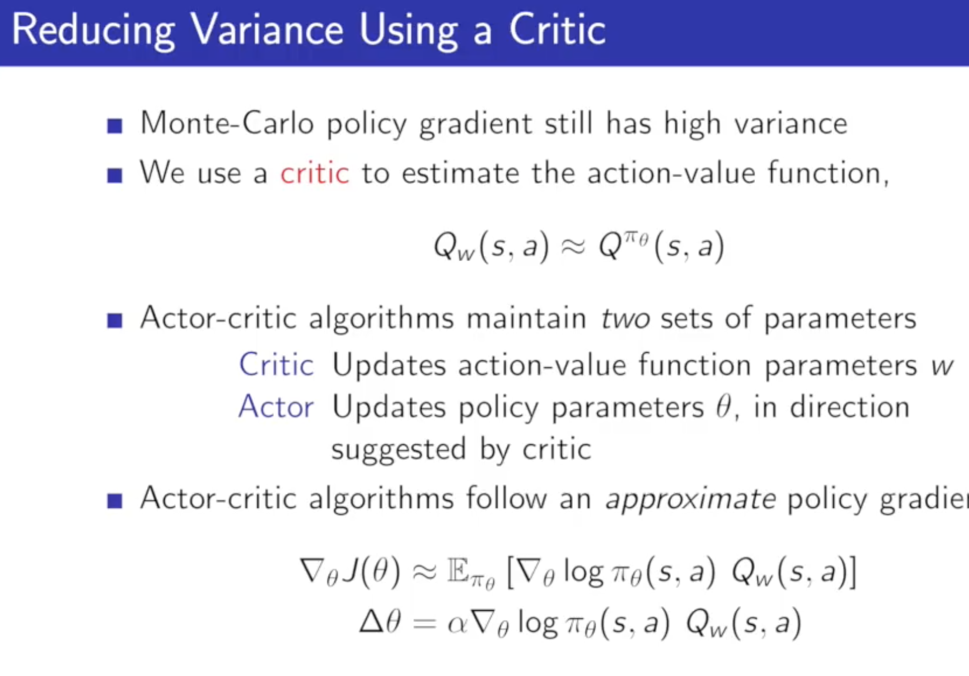

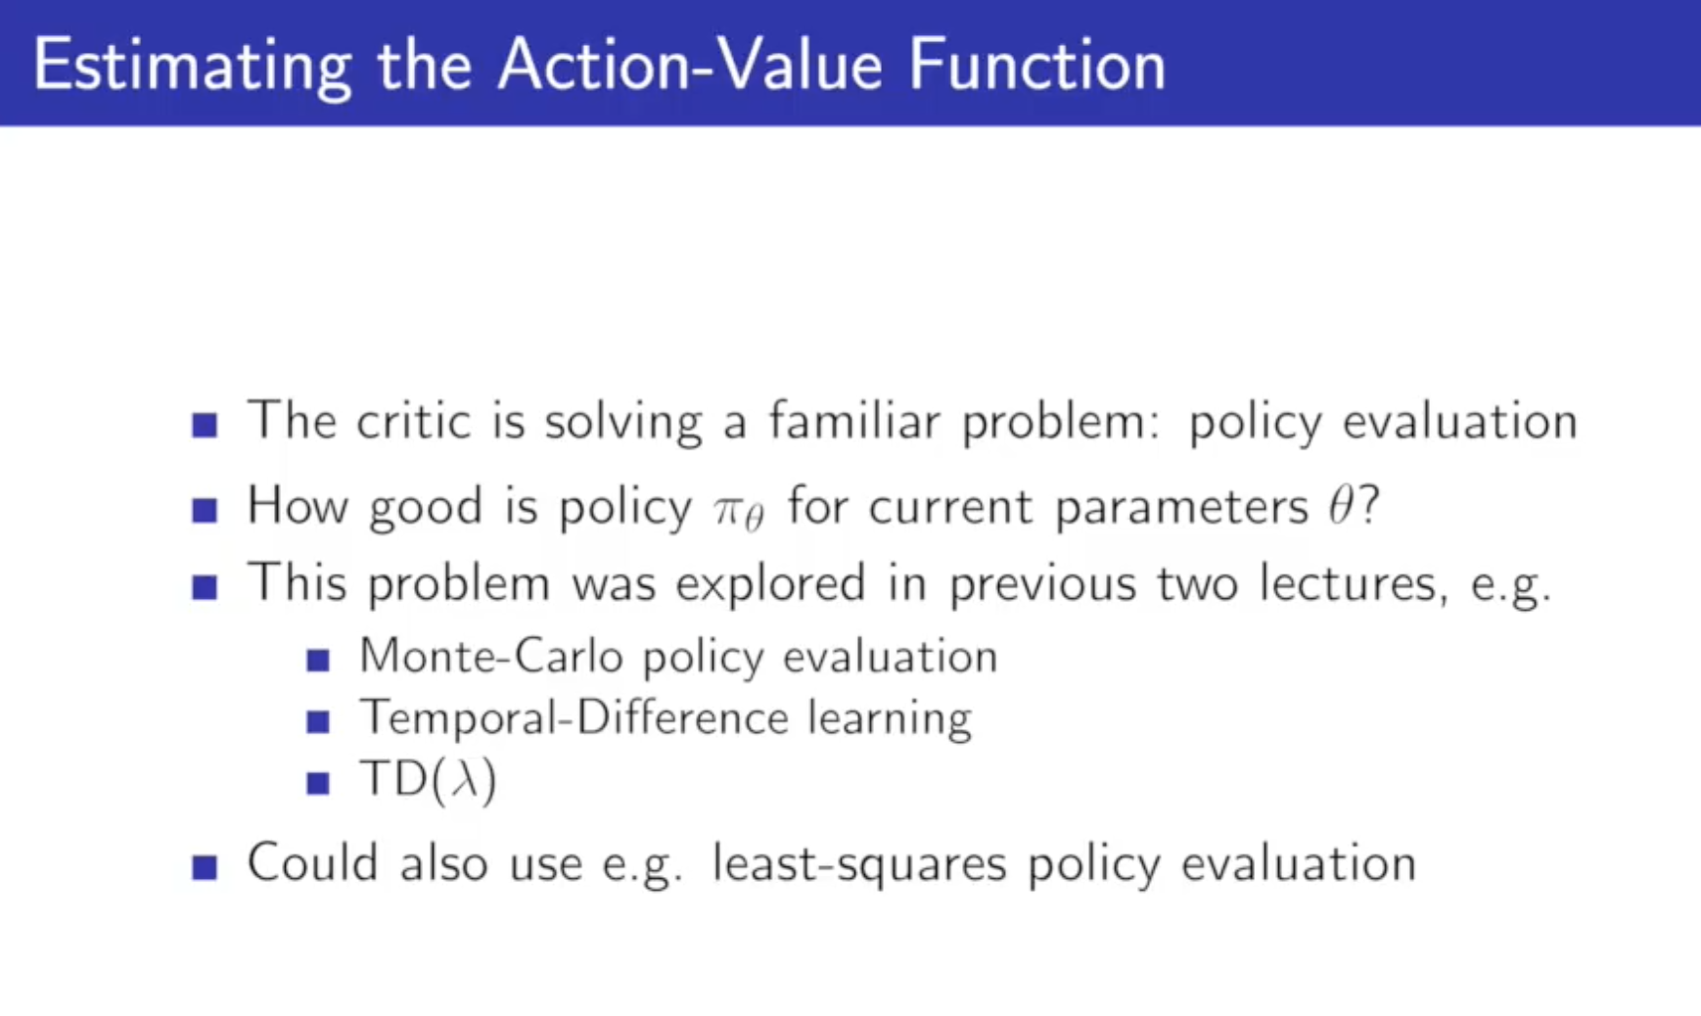

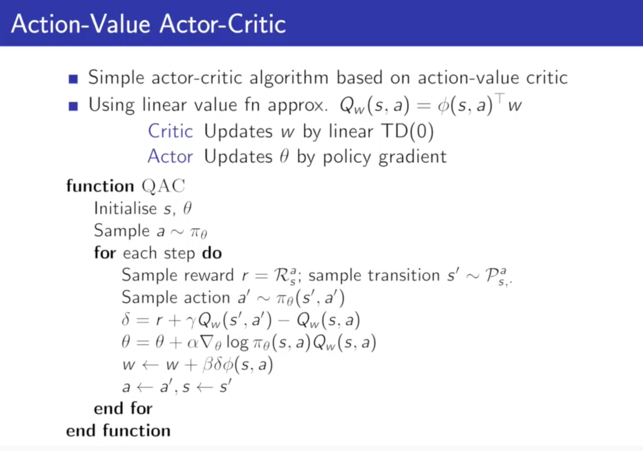

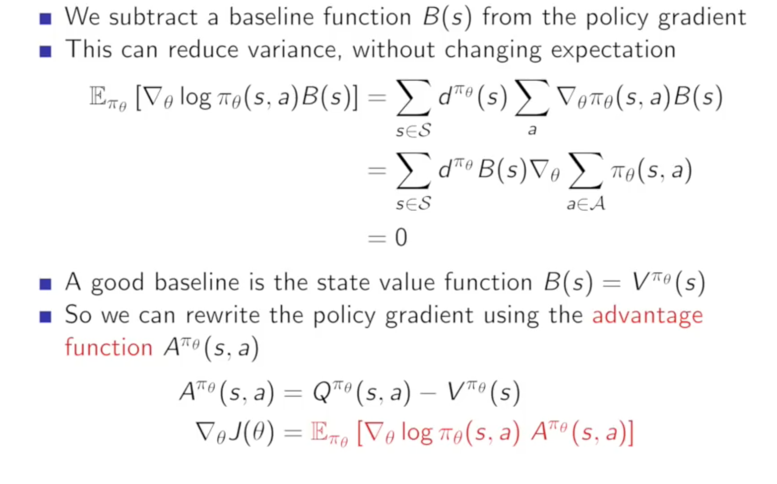

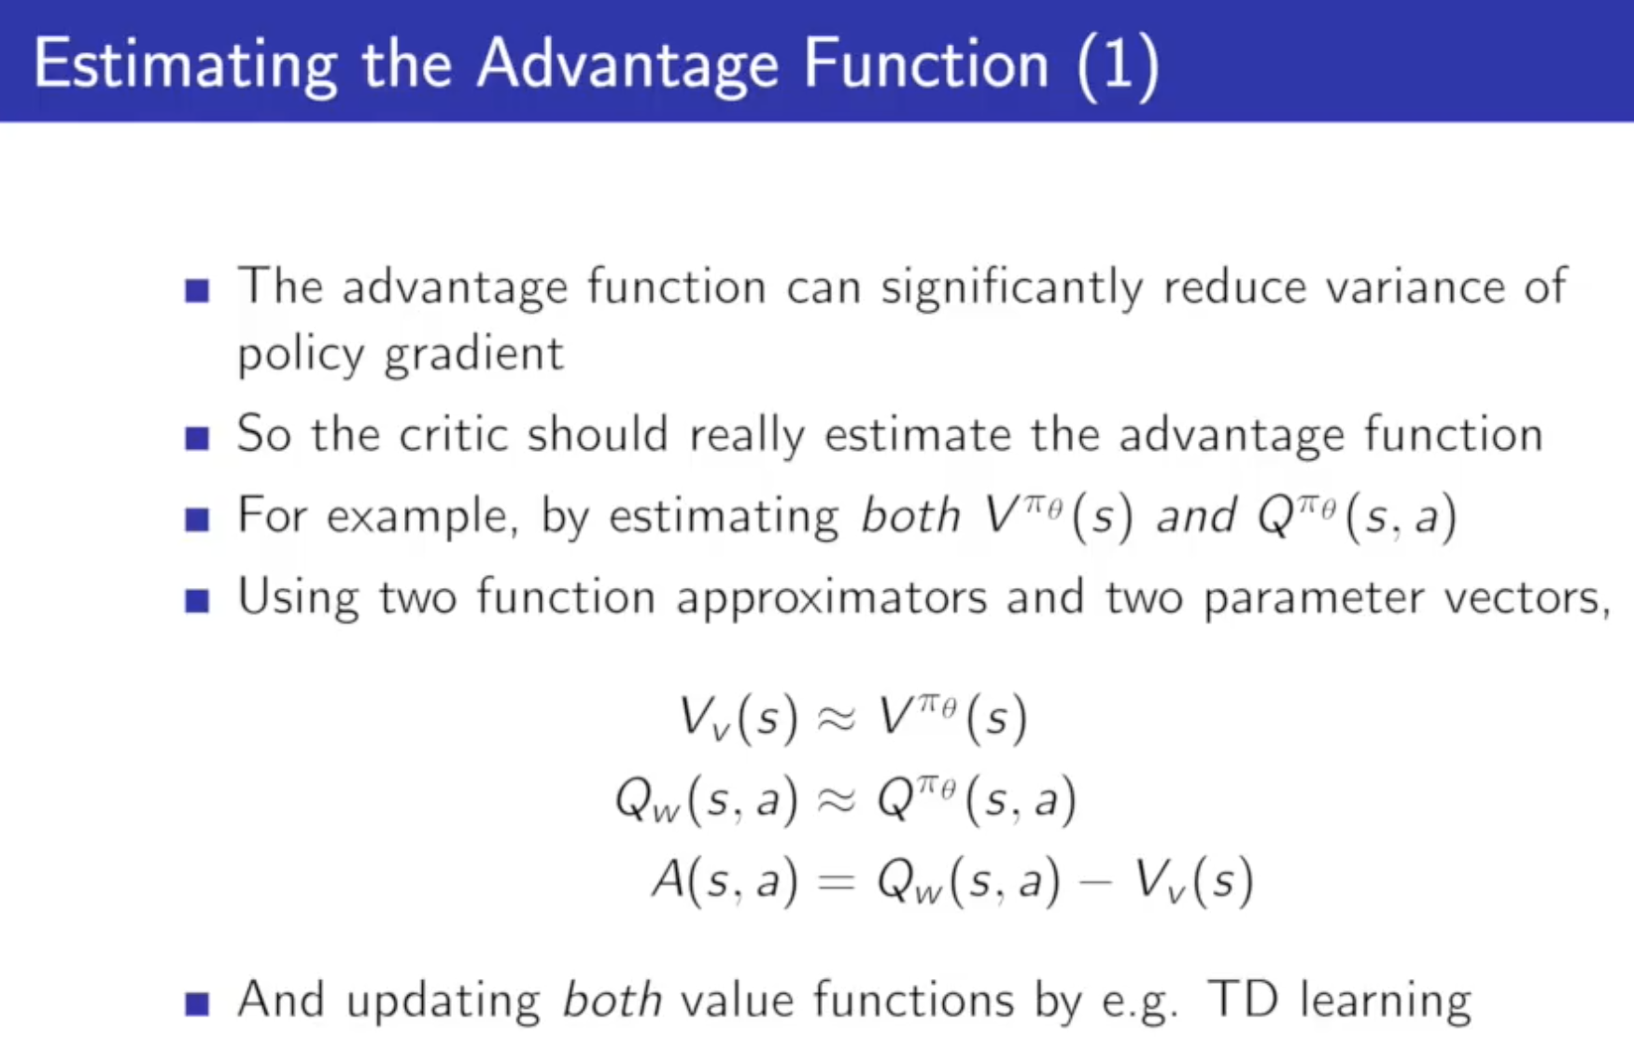

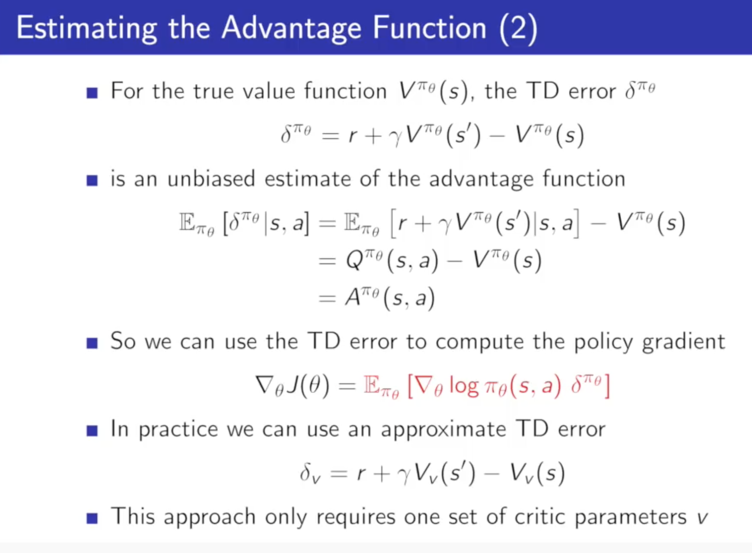

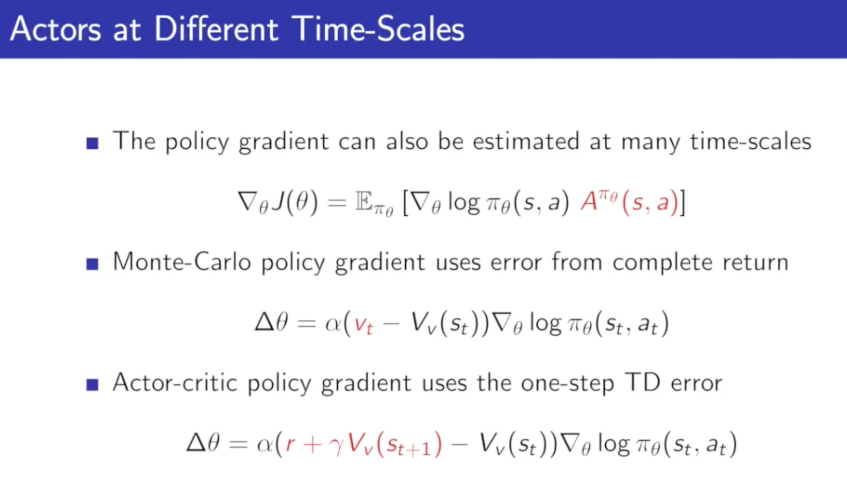

## Continues Actor critic

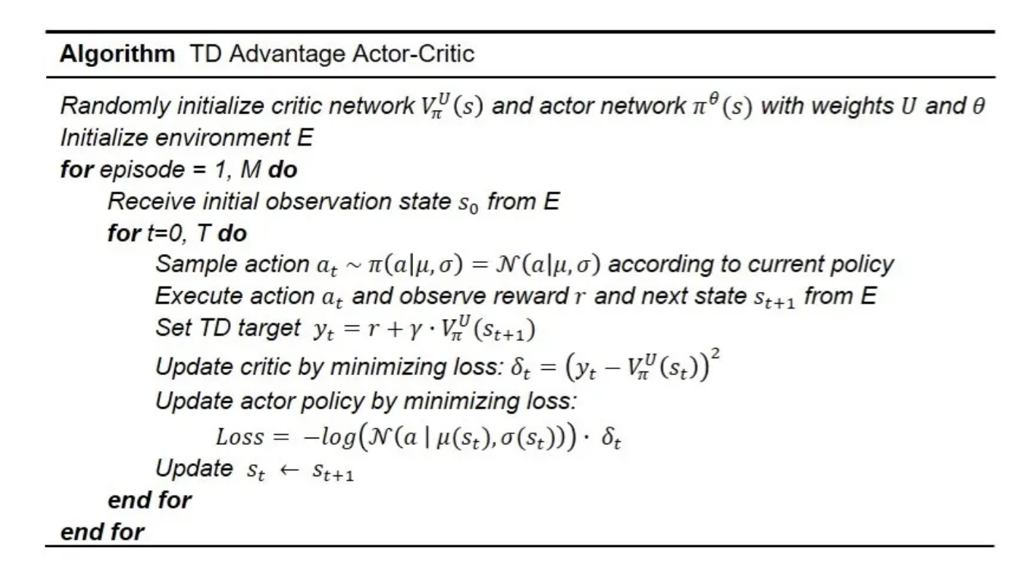

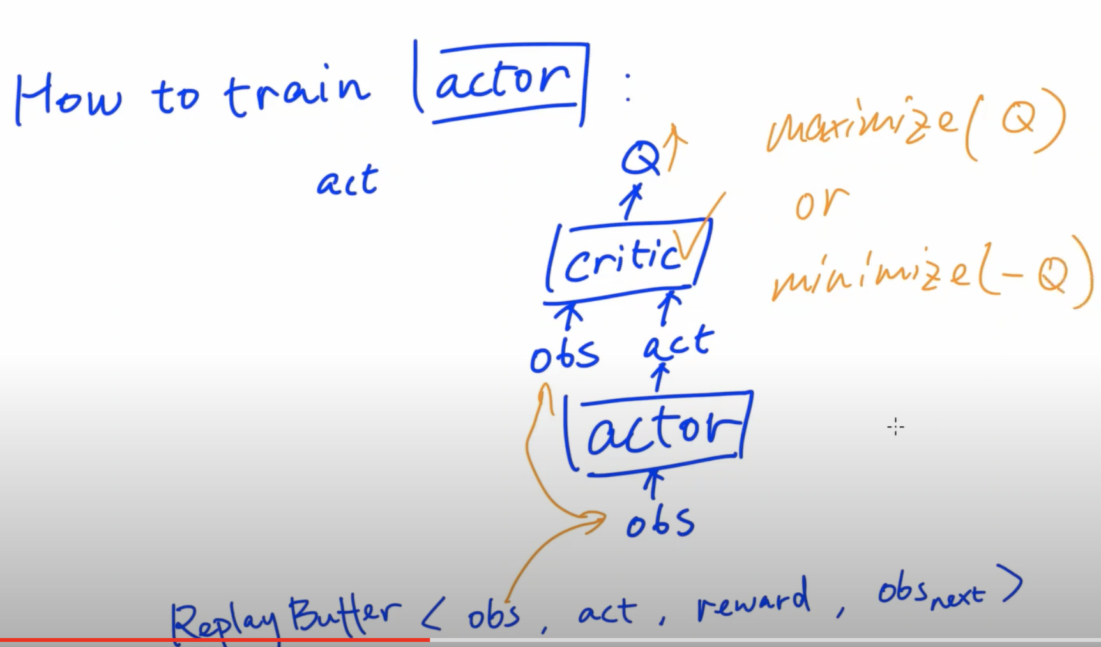

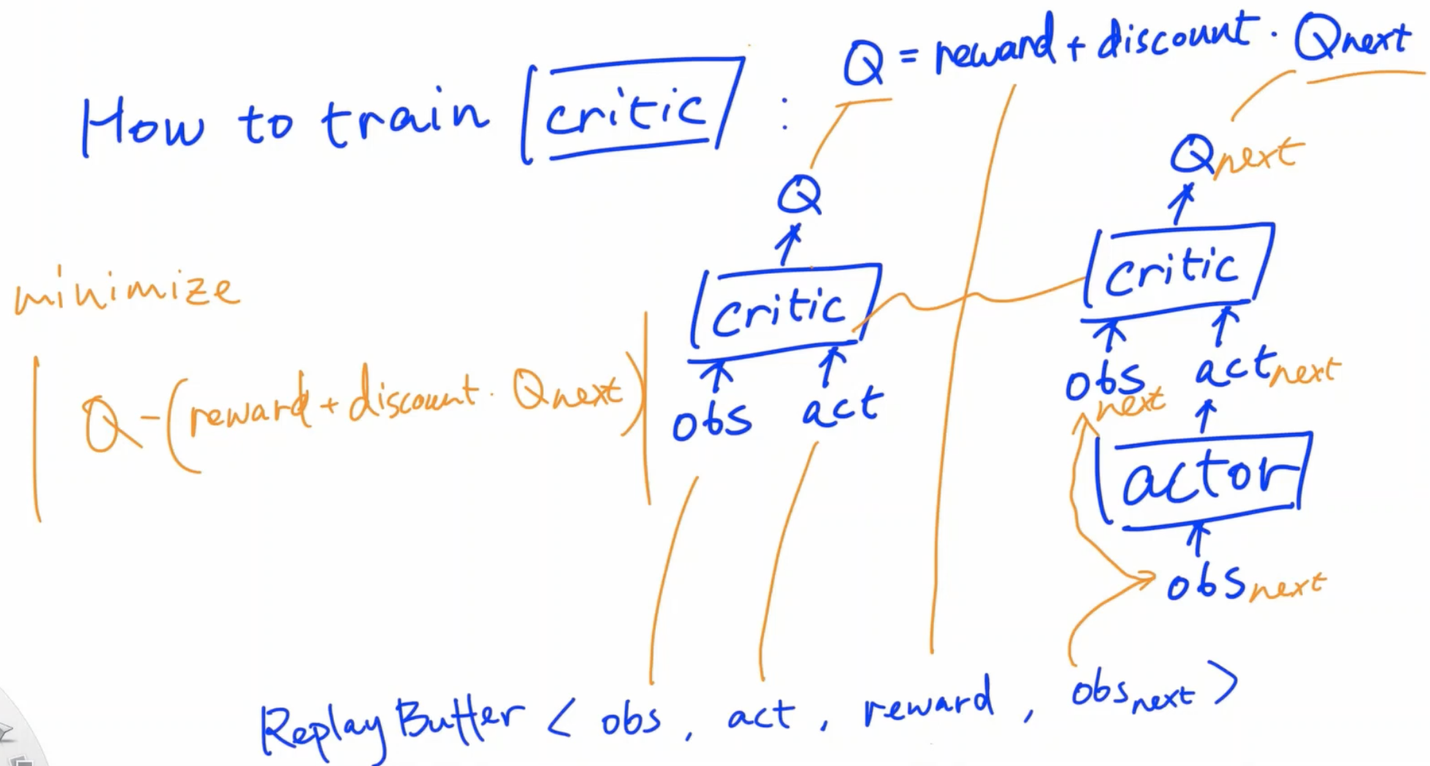

## DDPG:

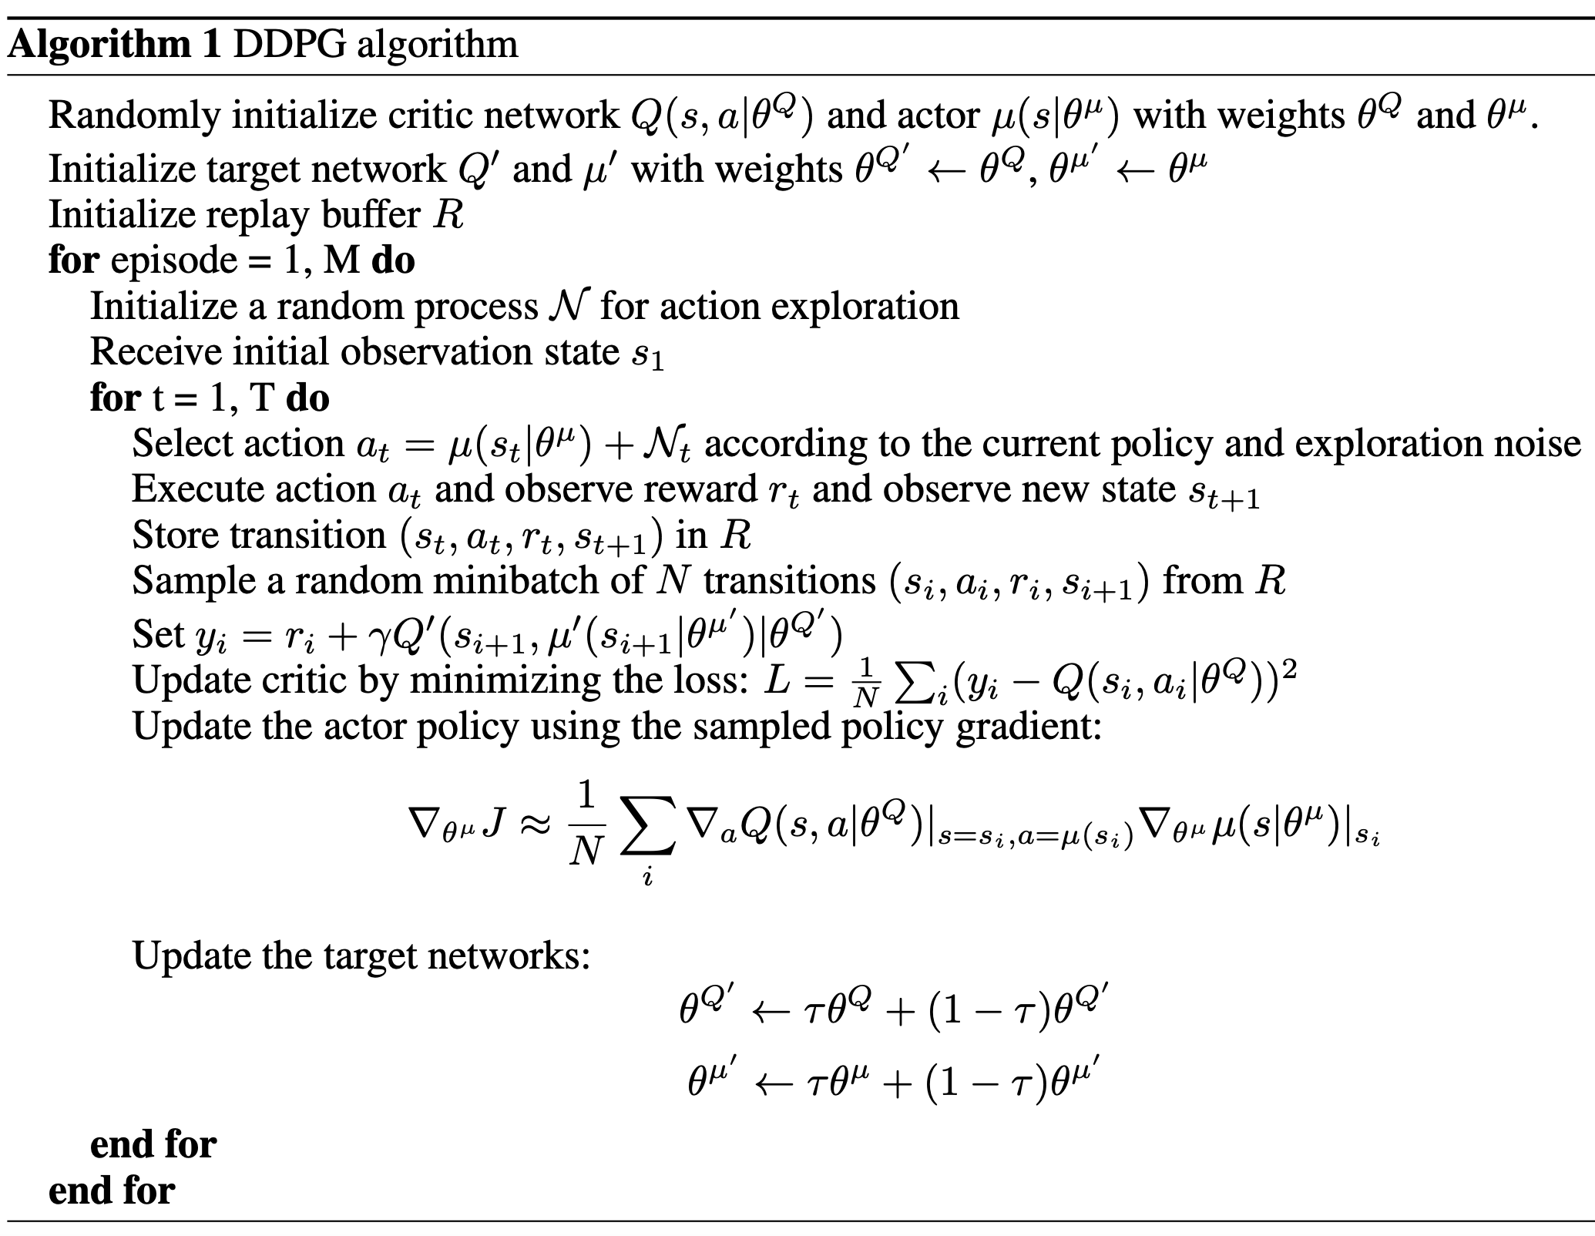

## Soft Learning (SAC):

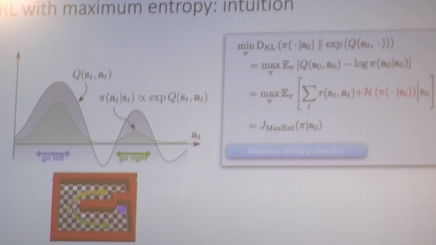

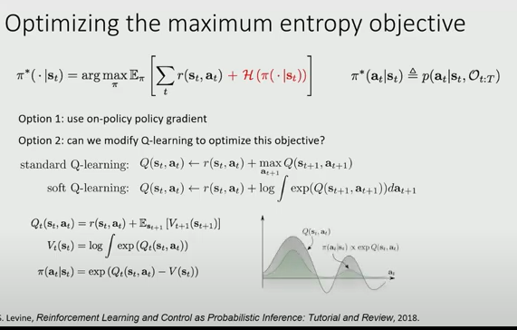

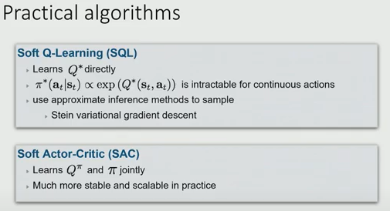

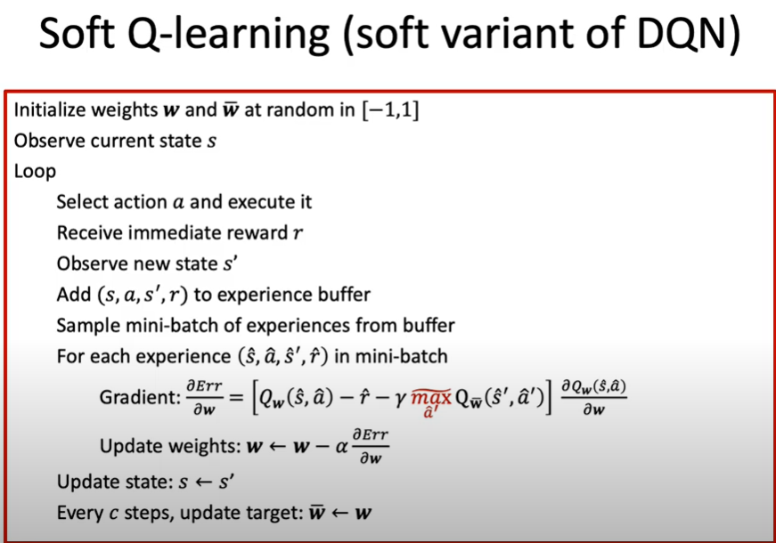

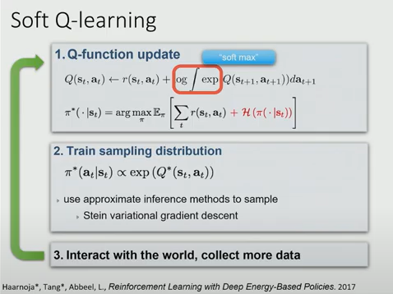

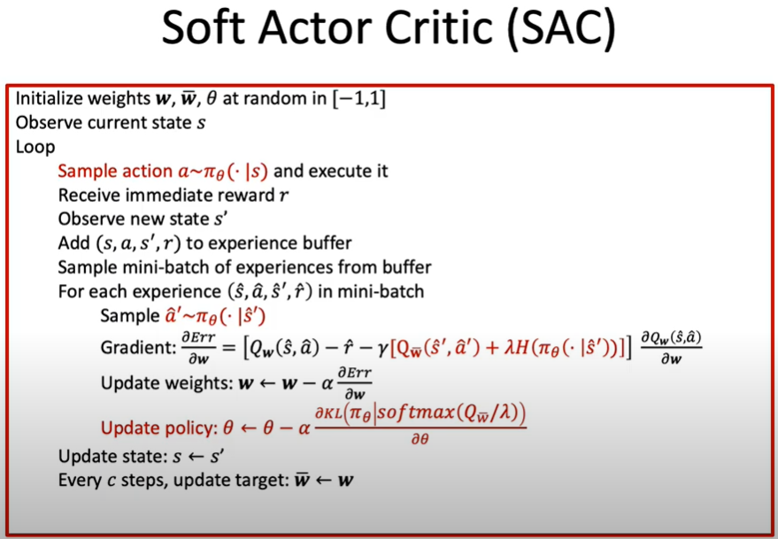

See the link:

<https://spinningup.openai.com/en/latest/algorithms/sac.html>

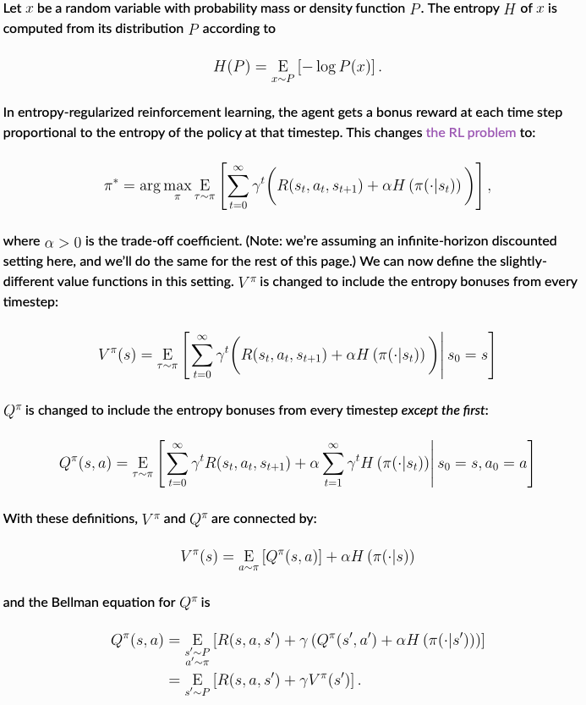

## Gradient of expectation:

**See this page:** http://stillbreeze.github.io/REINFORCE-vs-Reparameterization-trick/

Likelihood-ratio gradient/ Score Function/Reinforce:

An example: [Stochastic Computation Graphs - Sebastian Nowozins slow blog](http://www.nowozin.net/sebastian/blog/stochastic-computation-graphs.html)

**Setup**: We're trying to optimize a function of the form

**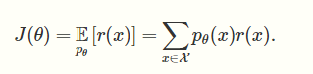**

Combined with stochastic gradient ascent, the likelihood-ratio gradient estimator is an approach for solving such a problem. It appears in policy gradient methods for reinforcement learning (e.g., [Sutton et al. 1999](https://papers.nips.cc/paper/1713-policy-gradient-methods-for-reinforcement-learning-with-function-approximation.pdf)), black-box optimization (e.g., [Wierstra et al. 2011](https://arxiv.org/abs/1106.4487)), and [causal reasoning](https://timvieira.github.io/blog/post/2016/12/19/counterfactual-reasoning-and-learning-from-logged-data/). There are two main ideas in the trick: (1) the "score function" estimator and (2) the cancelation of complicating factors.

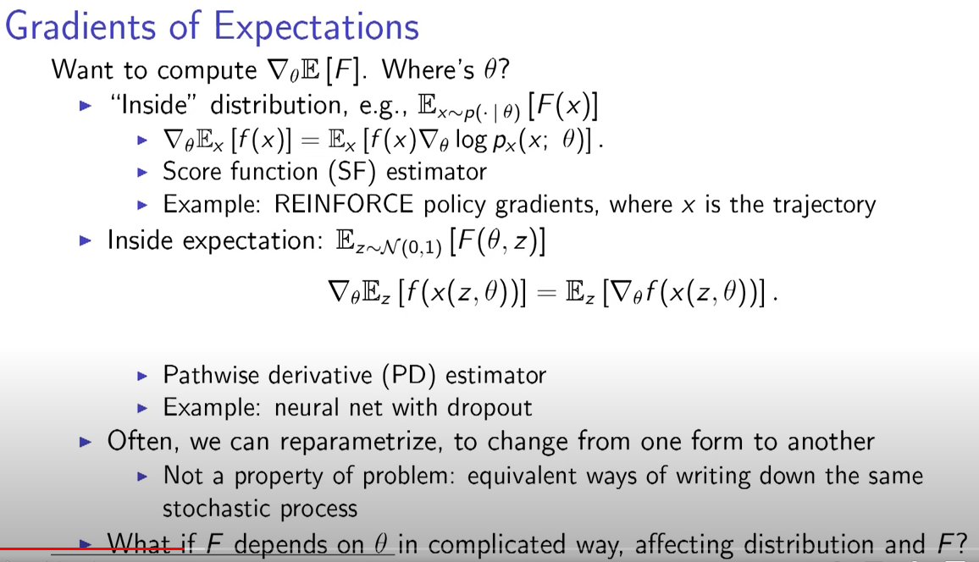

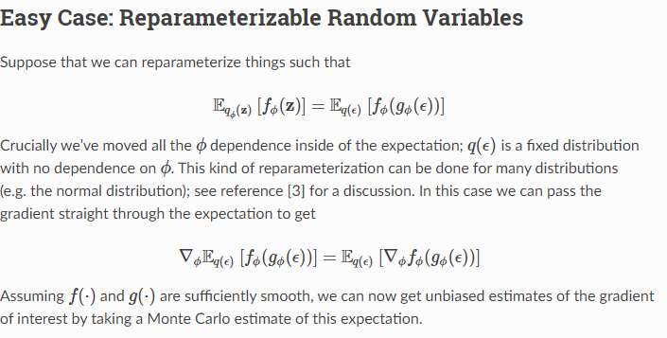

**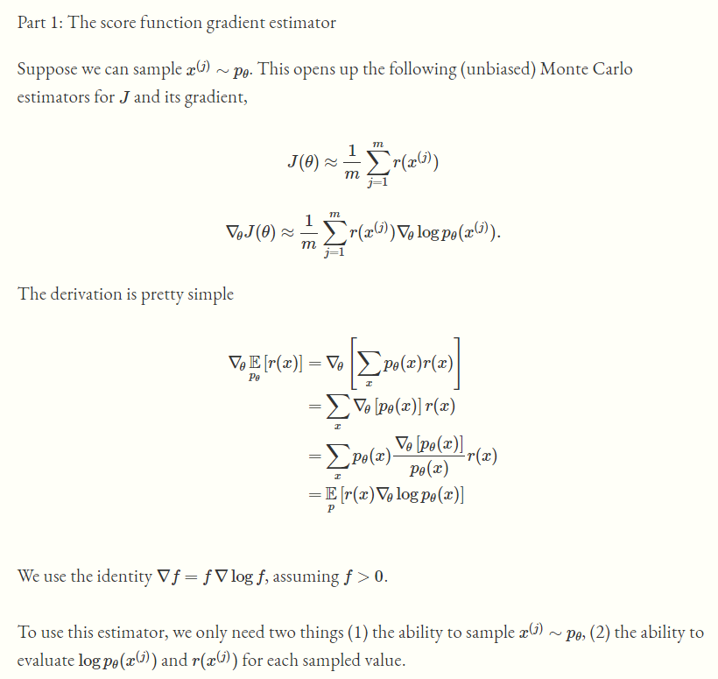**

**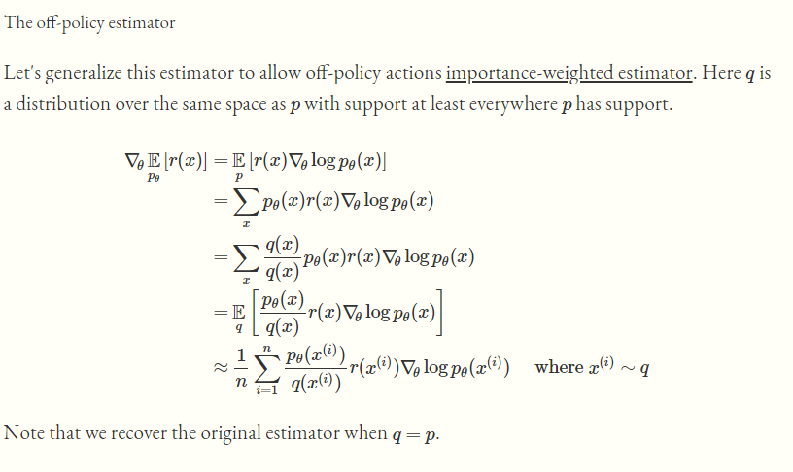**

## Score Function.

**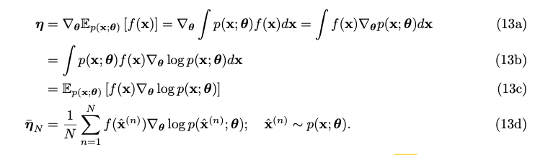**

## Path wise:

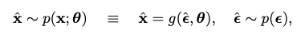

**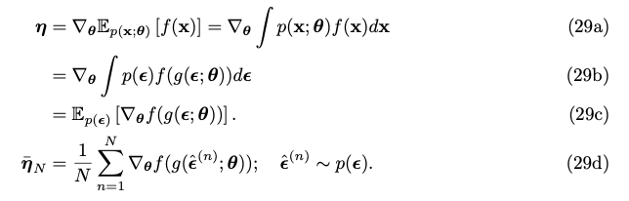**

## Research Ideas:

* Offline continues policy gradient: from paper: Off-Policy Actor-Critic from page 3. Does the offline means it can directly use the log data? But how to get the behaviors policy.?

## loss.backward() computes dloss/dx for every parameter x which has requires\_grad=True.

When you call loss.backward(), all it does is to compute gradient of loss w.r.t all the parameters in loss that have requires\_grad = True and store them in parameter.grad attribute for every parameter.

optimizer.step() updates all the parameters based on parameter.grad

2: Recall that when initializing optimizer you explicitly tell it what parameters (tensors) of the model it should be updating. The gradients are "stored" by the tensors themselves (they have a [grad](https://pytorch.org/docs/master/autograd.html" \l "torch.Tensor.grad)and a [requires\_grad](https://pytorch.org/docs/master/autograd.html" \l "torch.Tensor.requires_grad) attributes) once you call backward() on the loss. After computing the gradients for all tensors in the model, calling optimizer.step() makes the optimizer iterate over all parameters (tensors) it is supposed to update and use their internally stored grad to update their values.

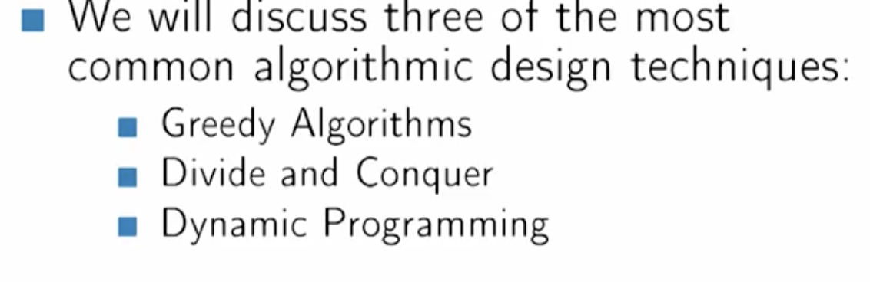 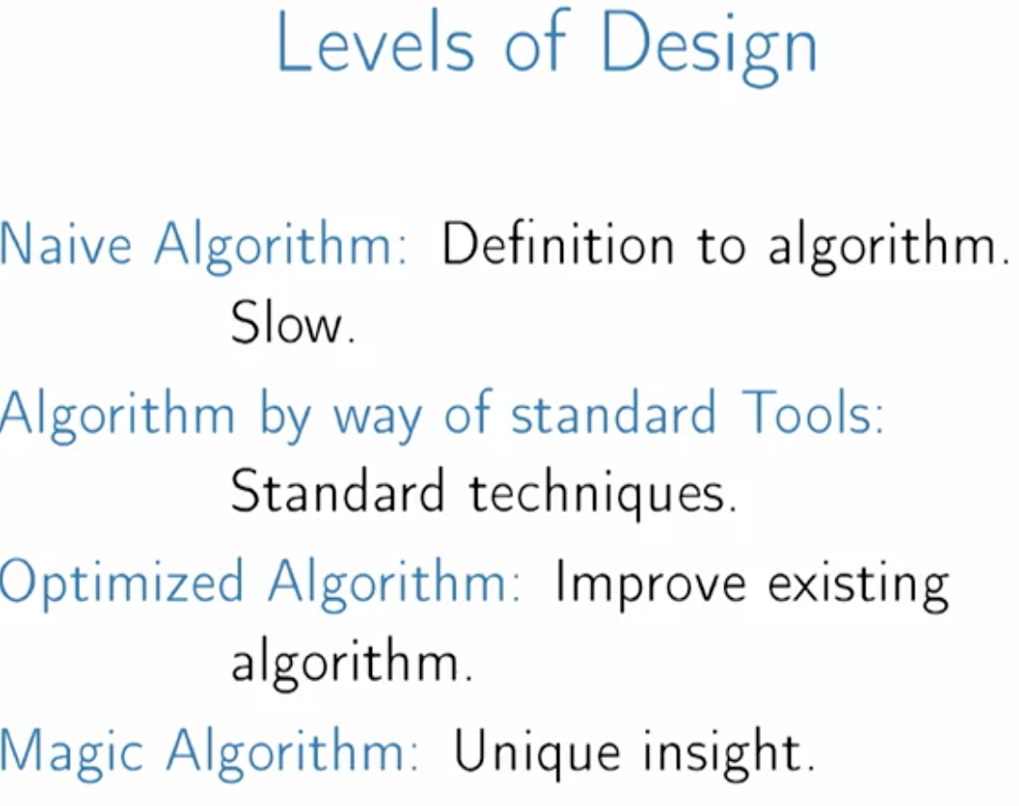



     Meal Preferences:  Vegan, Vegetarian, Carnivore, etc.

·       Meal Preparation Type:  prepared foods, meal kits, frozen, cook from scratch, etc.

·       Pet:  none, cat only, dog only, both, etc.

·       Alcohol:  none, moderate, heavy, etc.

·       Demographics:  baby, young children, elderly, etc.

·       Dietary:  Keto, South Beach, Atkins, etc.

·       Income:  upper to lower income, price sensitive, etc.

·       Ethnicity:  African American, Hispanic

aws lambda invoke \

--function-name prod-spark-datasci-control \

--payload '{"action":"provision", "masterNodeType": "m5.4xlarge", "python3": true,"coreNodeType":"m5.4xlarge","email":"m.wang@fetchrewards.com"}' \

out.log

Given the impression data at real time, it is possible to utilize user’s action and feedback on each offer and brand to optimize the offer and brand layout and offer push notification for each user. More specifically, we can build online

1: Brand and

2: Offer recommendation engine with the offer impression data.

They will be able to work real or near real time taking into user feedback on the offers and brand, so the engine can continuously optimize itself.

## DPG

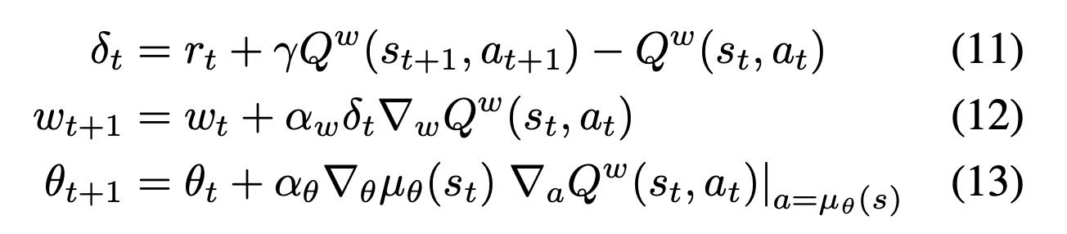

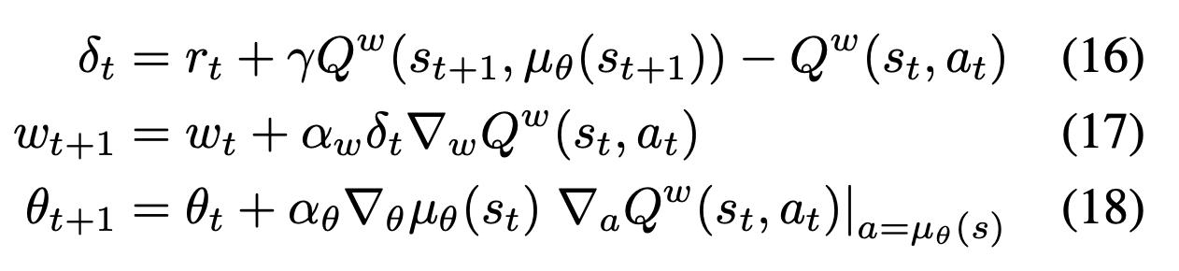

## KL Divergence

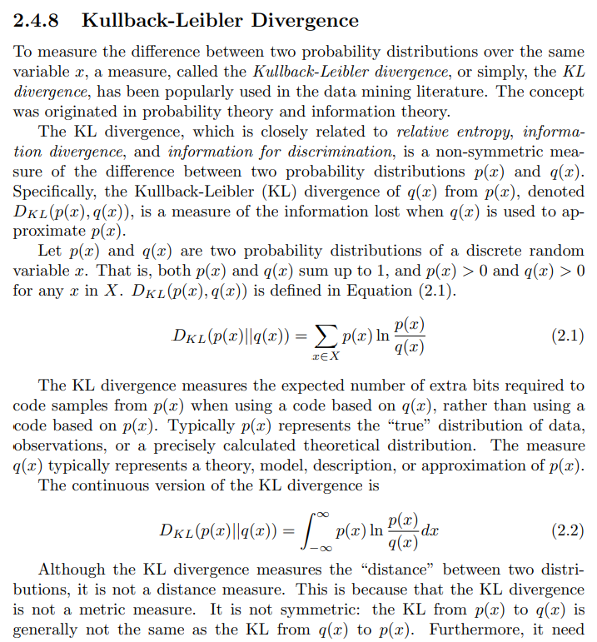

## Sample and Resample in Pytorch(Pathwise derivative)

sample and rsample both generate samples from the distribution, but only rsample supports differentiating through the sampler. You should use rsample whenever you need to compute gradients of distribution parameters with respect to functions of samples, e.g. in variational inference.

See [part 3 of the Pyro SVI tutorials 52](http://pyro.ai/examples/svi_part_iii.html#Easy-Case:-Reparameterizable-Random-Variables) for more discussion.

## [How to estimate a behavior policy for off-policy learning based on data?](https://ai.stackexchange.com/questions/20684/how-to-estimate-a-behavior-policy-for-off-policy-learning-based-on-data)

1:

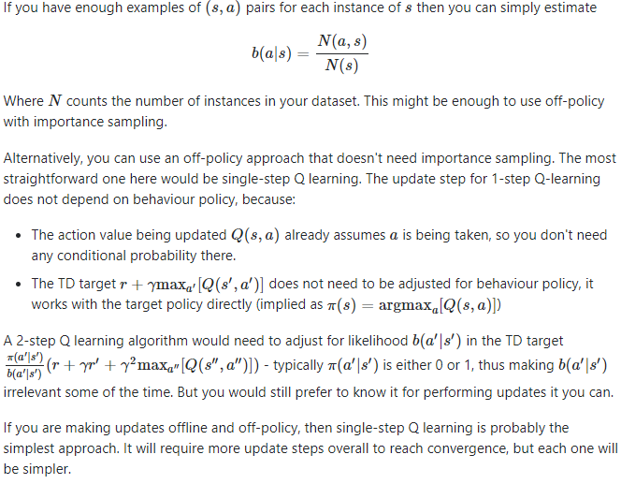

2: You can simply train a policy from the inputs to predict the actions in your dataset. You can use the cross entropy loss for this, i.e. maximize the the log probability that the policy assigns to the actions in the data set when given the corresponding inputs. This is called behavioral cloning. The result is an approximation of the behavioral policy that lets you compute probability densities of actions. It is an approximation because the dataset is finite, and even more so when you restrict the learned policy to a class of distributions, e.g. Gaussians.

## Off Policy Evaluation:

**1: (High confidence off-policy evaluation 2017).** Need to use the importance sampling

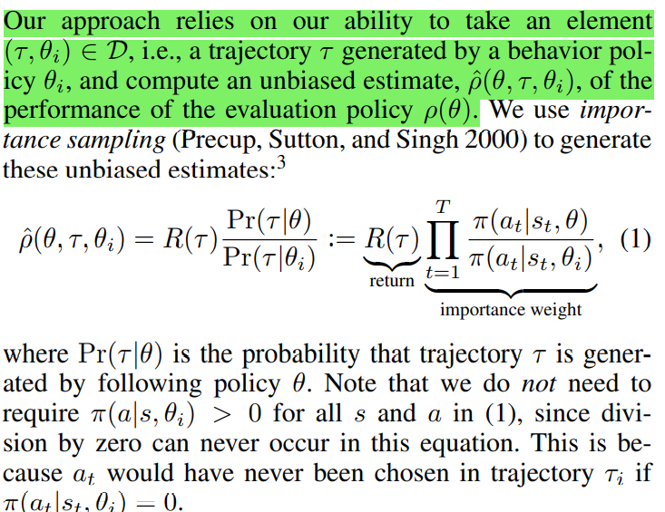

Steps for off-policy evaluation:

* Create a simulator
* Find out a behavior policy (Old system such as bandit models) and run against the simulator to obtain the data. Obtain the performance of the behavior policy.
* Using the data generated data from the behavior policy calculate the performance of the target policy, find out the low confident bound for the new policy.

2: For the recommendation system, it is not convenient to compute p(a|x) because of large space of actions available. We can sperate data into testing data and test out the performance in the testing period.

3: Three methods for off-line Policy’s evaluation:

1: Direct Method:

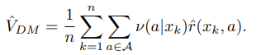

2: IPS (inverse Propensity Score):

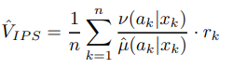

3: Doubly Robust Estimator:

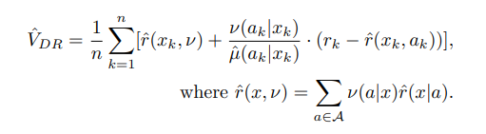

**OFFLINE POLICY EVALUATION IN A CONTEXTUAL BANDIT PROBLEM 2019**

Doubly Robust Policy Evaluation and Learning 2011

[Offline Policy Evaluation: Run fewer, better A/B tests | by Edoardo Conti | Medium](https://edoconti.medium.com/offline-policy-evaluation-run-fewer-better-a-b-tests-60ce8f93fa15)ss

4:

## Off Policy Actor Critic:

For more information, look at the page 210 in book: Reinforcement Learning: An introduction

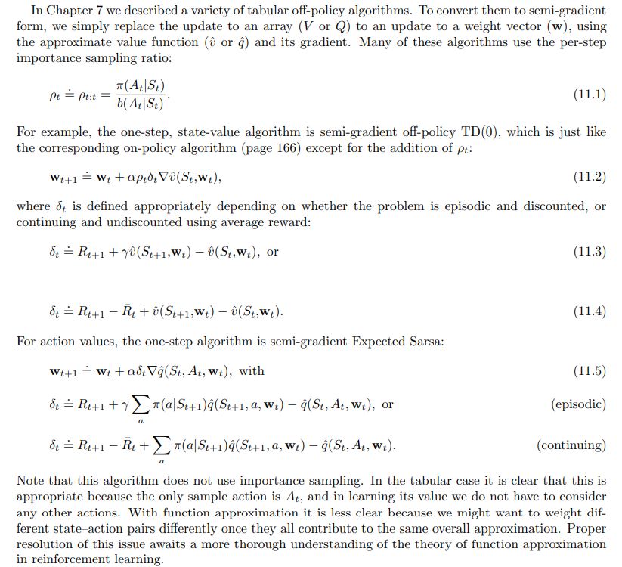

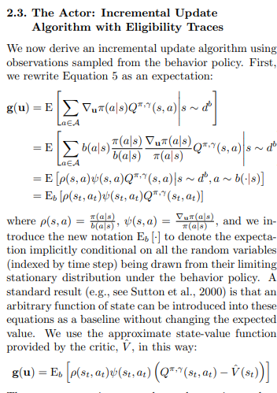

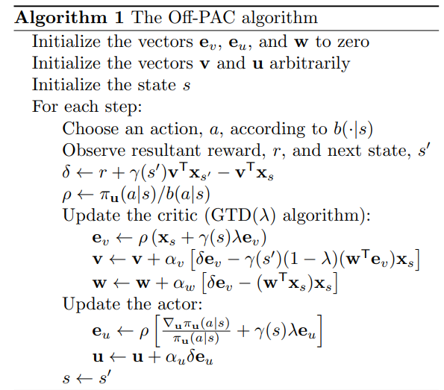

## Zero out the gradienst:

# Back

loss.backward()

T.grad[-1] = torch.zeros(3)

# Optimizer step

**with** torch.no\_grad():

T -= 0.01 \* T.grad

## How is Q-learning different from value iteration in reinforcement learning?

[artificial intelligence - What is the difference between Q-learning and Value Iteration? - Stack Overflow](https://stackoverflow.com/questions/28937803/what-is-the-difference-between-q-learning-and-value-iteration)

I know Q-learning is model-free and training samples are transitions (s, a, s', r). But since we know the transitions and the reward for every transition in Q-learning, is it not the same as model-based learning where we know the reward for a state and action pair, and the transitions for every action from a state (be it stochastic or deterministic)? I do not understand the difference.

You are 100% right that if we knew the transition probabilities and reward for every transition in Q-learning, it would be pretty unclear why we would use it instead of model-based learning or how it wssould even be fundamentally different. After all, transition probabilities and rewards are the two components of the model used in value iteration - if you have them, you have a model.

The key is that, **in Q-learning, the agent does not know state transition probabilities or rewards**. The agent only discovers that there is a reward for going from one state to another via a given action when it does so and receives a reward. Similarly, it only figures out what transitions are available from a given state by ending up in that state and looking at its options. If state transitions are stochastic, it learns the probability of transitioning between states by observing how frequently different transitions occur.

A possible source of confusion here is that you, as the programmer, might know exactly how rewards and state transitions are set up. In fact, when you're first designing a system, odds are that you do as this is pretty important to debugging and verifying that your approach works. But you never tell the agent any of this - instead you force it to learn on its own through trial and error. **This is important if you want to create an agent that is capable of entering a new situation that you don't have any prior knowledge about and figuring out what to do.** Alternately, if you don't care about the agent's ability to learn on its own, **Q-learning might also be necessary if the state-space is too large to repeatedly enumerate.** Having the agent explore without any starting knowledge can be more computationally tractable.

1. [enigma-project-prod](https://s3.console.aws.amazon.com/s3/buckets/enigma-project-prod)/[models/](https://s3.console.aws.amazon.com/s3/buckets/enigma-project-prod?prefix=models/)[rcom\_daily\_gross\_merch\_sales\_amt\_forecast/](https://s3.console.aws.amazon.com/s3/buckets/enigma-project-prod?prefix=models/rcom_daily_gross_merch_sales_amt_forecast/)[latest](https://s3.console.aws.amazon.com/s3/buckets/enigma-project-prod?prefix=models/rcom_daily_gross_merch_sales_amt_forecast/latest/)

## Natural Gradient Policy:

1: what is Fisher information Matrix?

## Gradient of Expectation

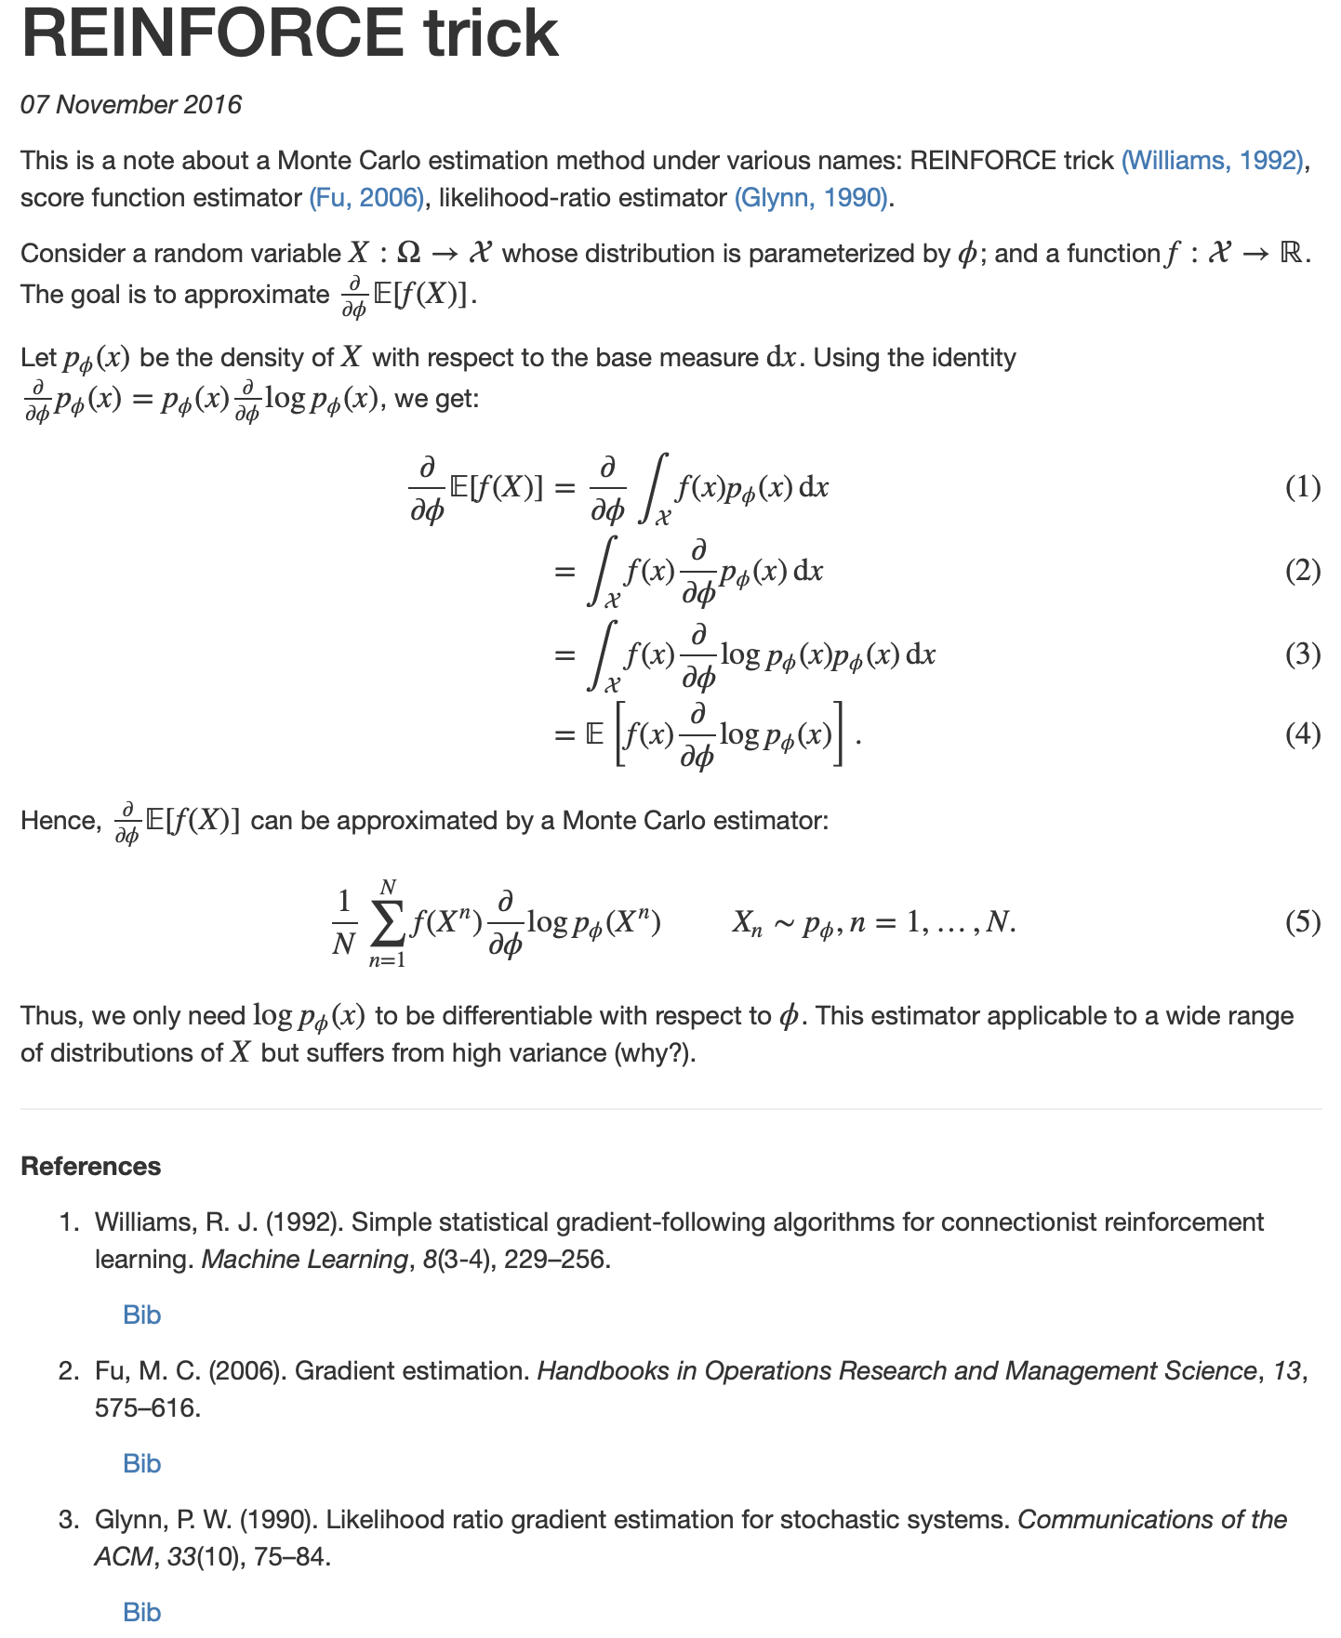

## Fisher Information Matrix

Suppose we have a model parameterized by parameter vector θ that models a distribution p(x|θ). In frequentist statistics, the way we learn θ is to maximize the likelihood p(x|θ) wrt. parameter θ. To assess the goodness of our estimate of θ we define a score function:

s(θ)=∇θlogp(x|θ),

that is, score function is the gradient of log likelihood function. The result about score function below is important building block on our discussion.

**Claim:** The expected value of score wrt. our model is zero.

*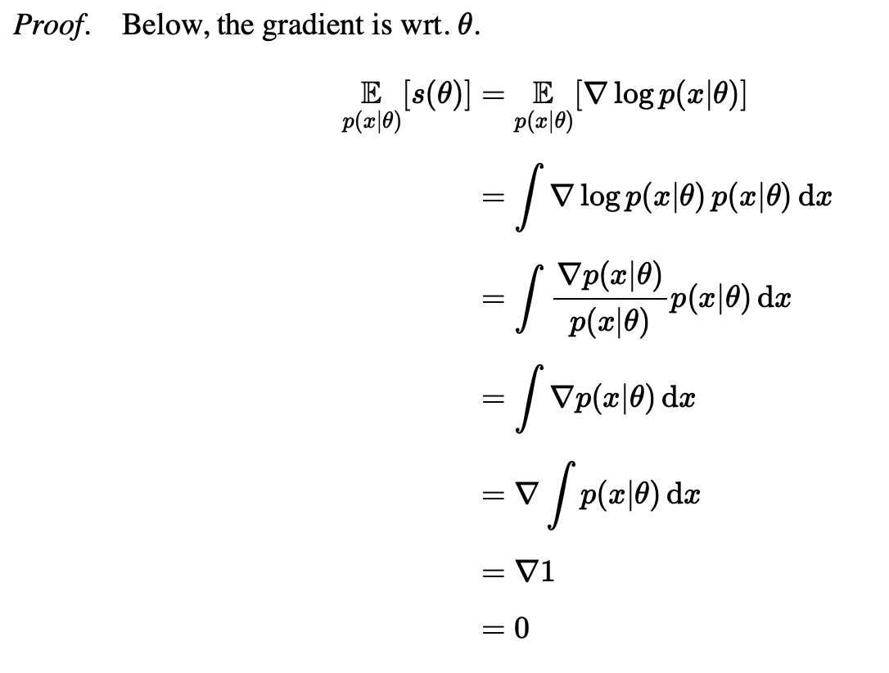*

But how certain are we to our estimate? We can define an uncertainty measure around the expected estimate. That is, we look at the covariance of score of our model. Taking the result from above:

Ep(x|θ)[(s(θ)−0)(s(θ)−0)T].

We can then see it as an information. The covariance of score function above is the definition of Fisher Information. As we assume θ is a vector, the Fisher Information is in a matrix form, called Fisher Information Matrix:

F=Ep(x|θ)[∇logp(x|θ)∇logp(x|θ)T].

However, usually our likelihood function is complicated and computing the expectation is intractable. We can approximate the expectation in F using empirical distribution ^q(x), which is given by our training data X={x1,x2,⋯,xN}. In this form, F is called Empirical Fisher:

F=1NN∑i=1∇logp(xi|θ)∇logp(xi|θ)T.

## Clone and Detach:

A good example: <https://androidkt.com/how-to-copy-pytorch-tensor-using-clone-detach-and-deepcopy/>

1: When the clone method is used, torch allocates a new memory to the returned variable but using the detach method, the same memory address is used.

2: clone() is useful to create a copy of the original variable that doesn’t forget the history of ops so it allows gradient flow and **avoids errors with inlace ops**. The main error of in-place ops is overwriting data needed for the backward pass or writing an in-place op to a leaf node, in this case, there would be no error message.

3: tensor.detach() creates a tensor that shares storage with a tensor that does not require grad. You should use detach() when attempting to remove a tensor from a computation graph and clone it as a way to copy the tensor while still keeping the copy as a part of the computation graph it came from.

4: a = torch.ones(5, requires\_grad=True)

b = a\*\*2

c = a.detach()

c.zero\_()

b.sum().backward()

print(a.grad)

It detects that ‘a’ has changed inplace and this will trip gradient calculation. It is because .detach() doesn’t implicitly create a copy of the tensor, so when the tensor is modified later, it’s updating the tensor on the upstream side of .detach() too. By cloning first, this issue doesn’t arise.

## Transformer

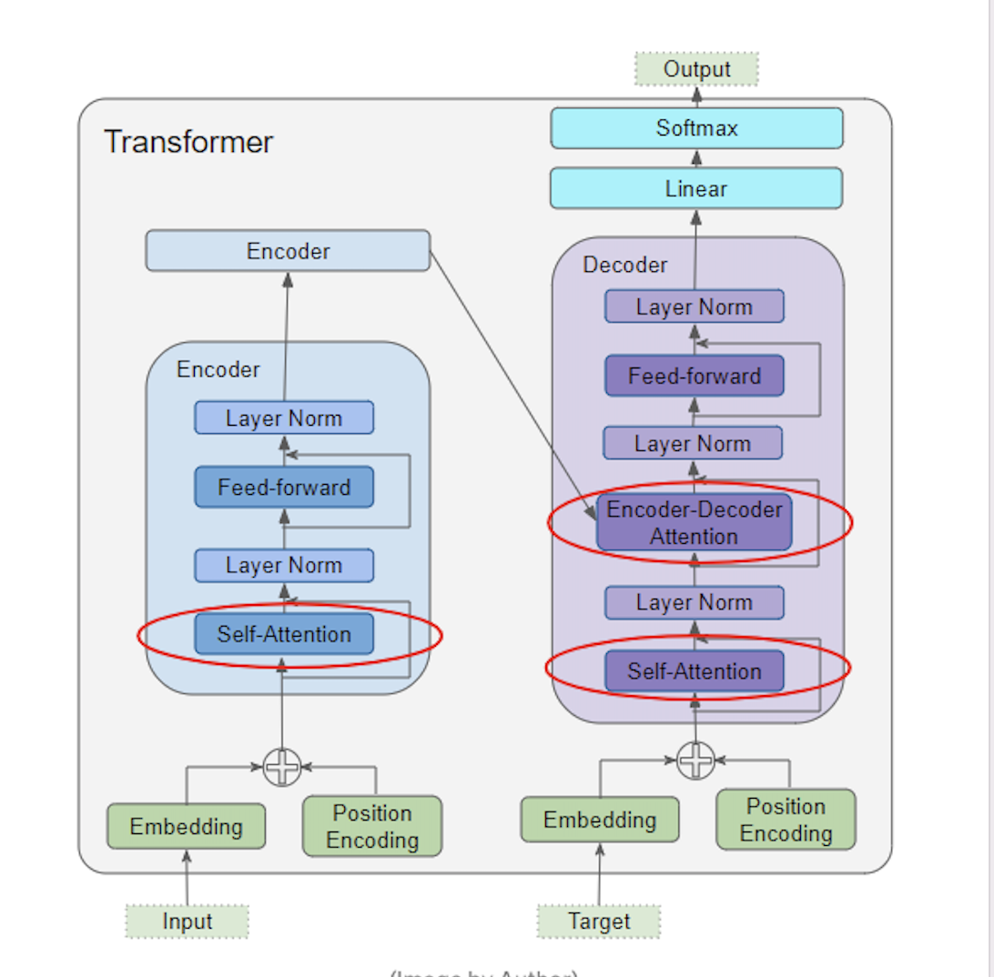

## Dyna-Q:

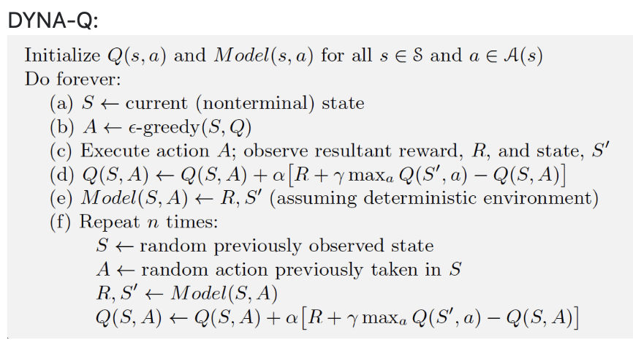

## Bellman Equation

State Value:

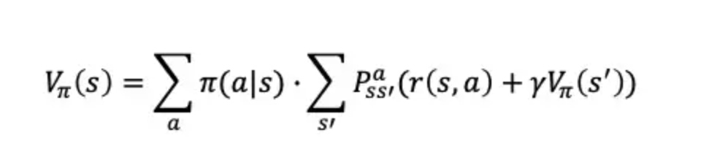

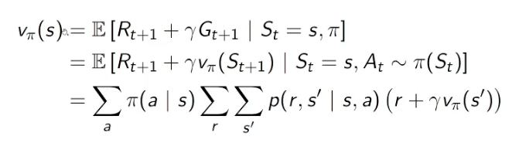

Action value:

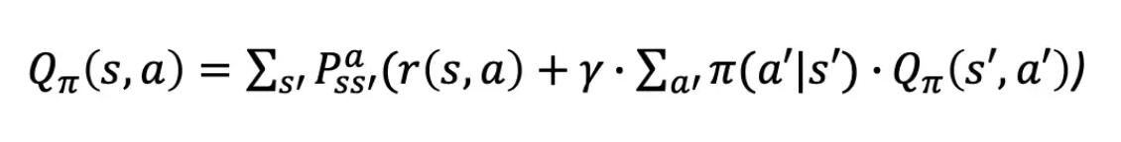

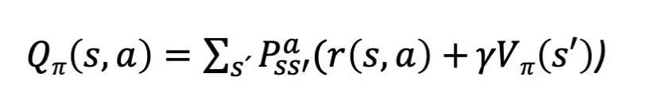 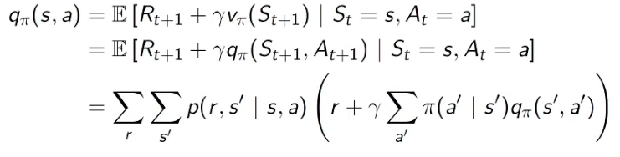



Final:

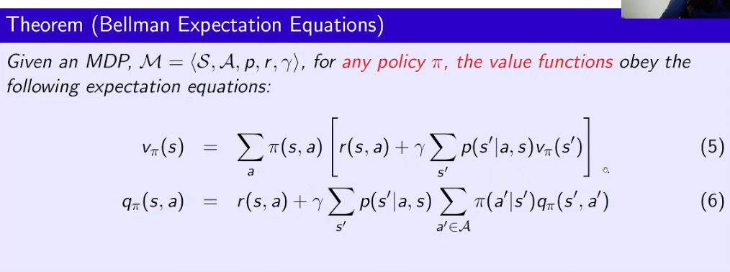

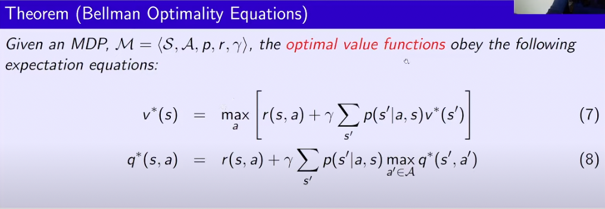

## Policy/Value Iteration

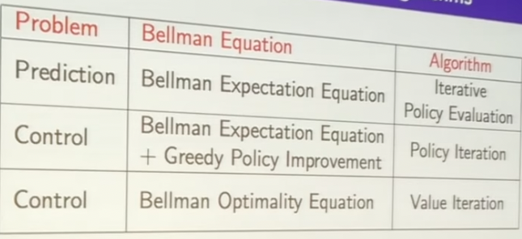

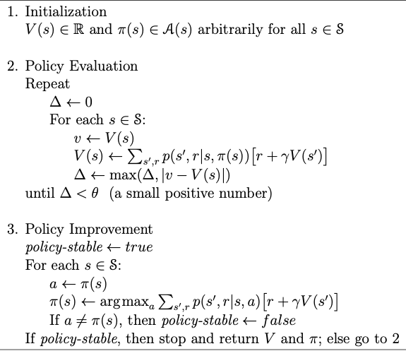

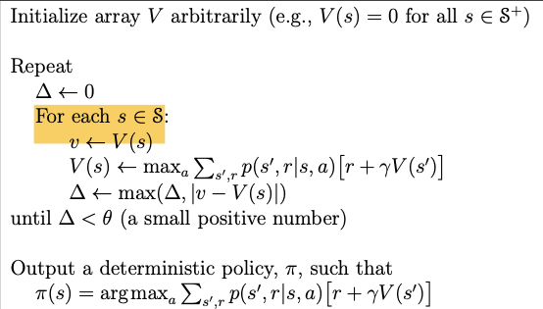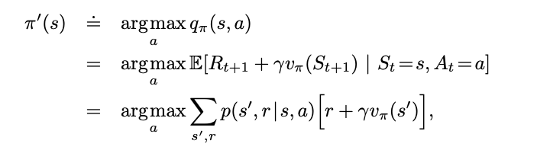

## g and Value iteration

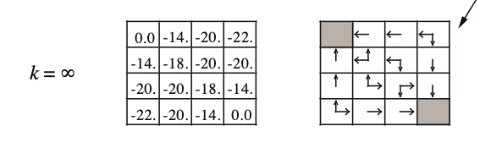

# Cross Entropy loss

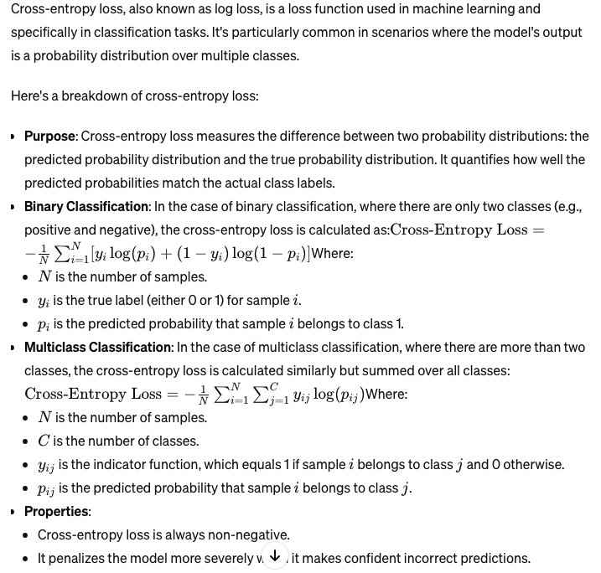

<https://www.linkedin.com/jobs/search/?currentJobId=3848705184&keywords=consumer%20packaged%20goods&location=chicago%20il>

<https://www.linkedin.com/jobs/search/?currentJobId=3829631054&keywords=consumer%20packaged%20goods&location=chicago%20il>

<https://www.linkedin.com/jobs/search/?currentJobId=3831548259&keywords=consumer%20packaged%20goods&location=chicago%20il>

ValueError: Expected shape ('b', 4800) but found (32, 18240)

# KL divergence

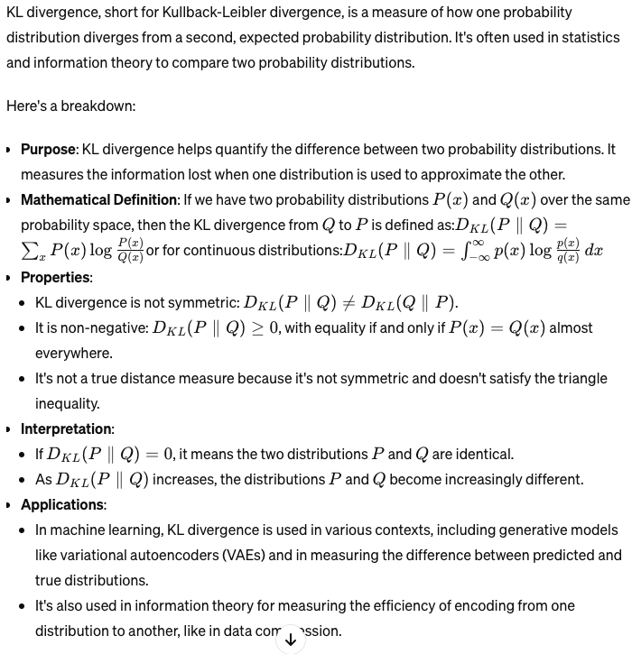

# Multi-Agent

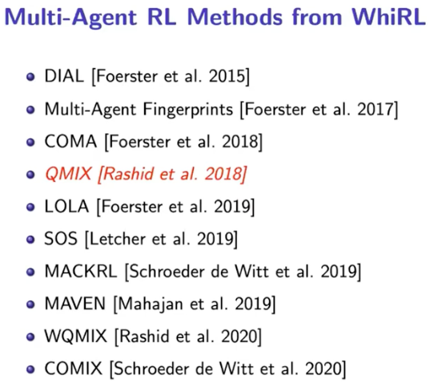

# Game definition.

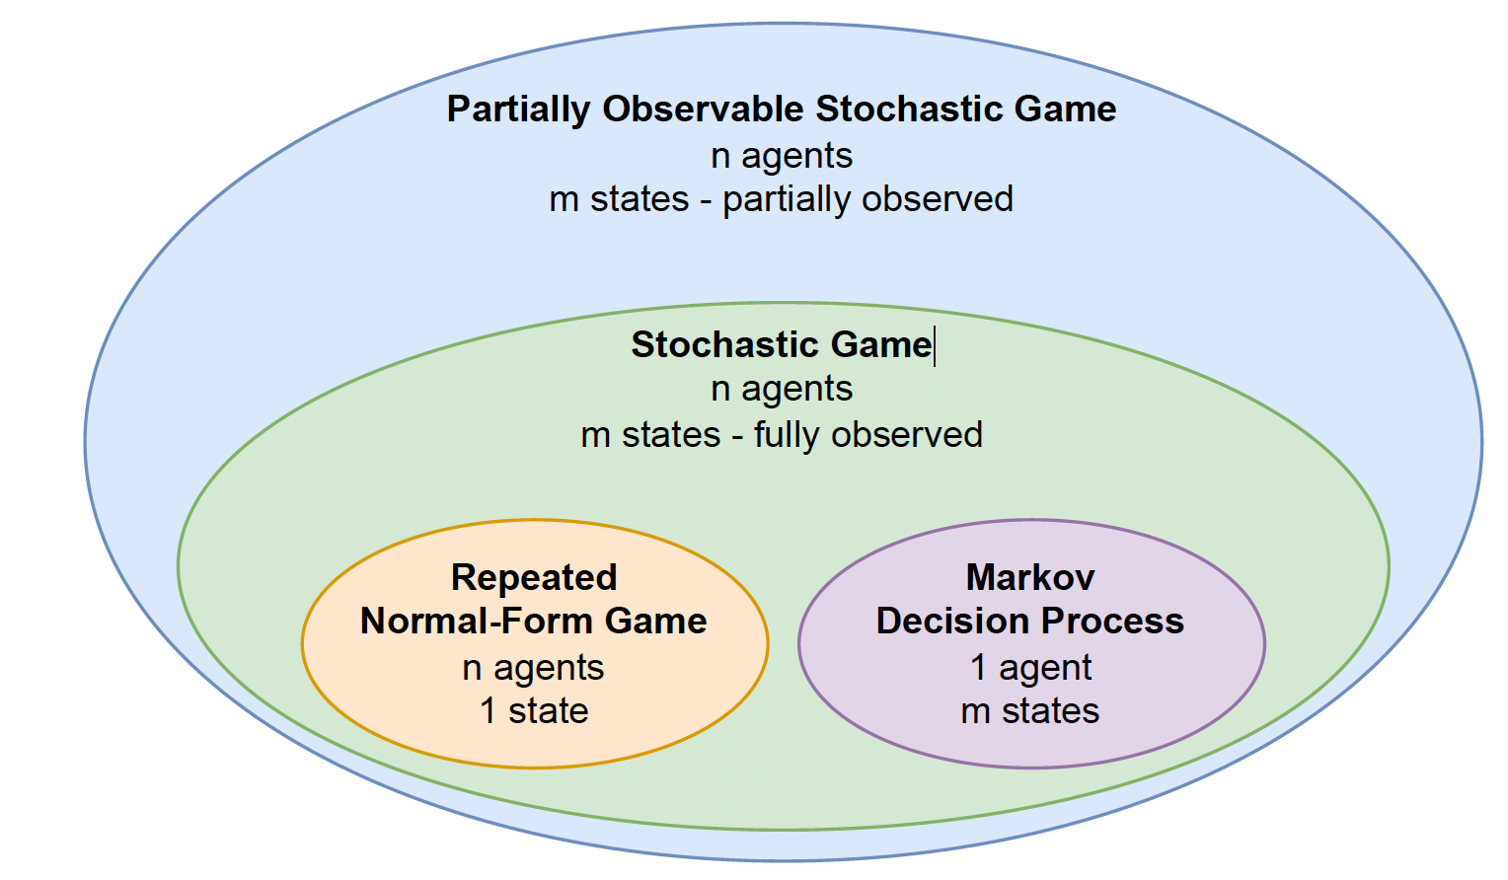

# Major Conference

NeurIPS, ICLR, ICML, VPR, ICCV,

**IEEE Symposium on Security and Privacy (IEEE S&P)**